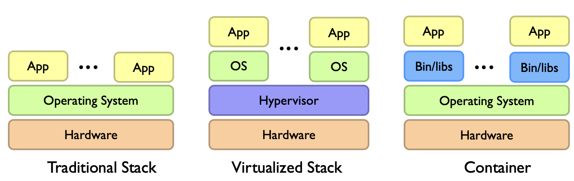

**Utility computing = Infrastructure as a Service (IaaS)**

* Rent cycle
* E.g. Amazon’s EC2, Rackspace, Google Compute Engine

**Platform as a Service (PaaS)**

* Provides hosting for web applications and takes care of the maintenance, upgrades
* E.g. Google App Engine

**Software as a Service (SaaS)**

* Just run it for me
* E.g. Gmail, Dropbox, Zoom

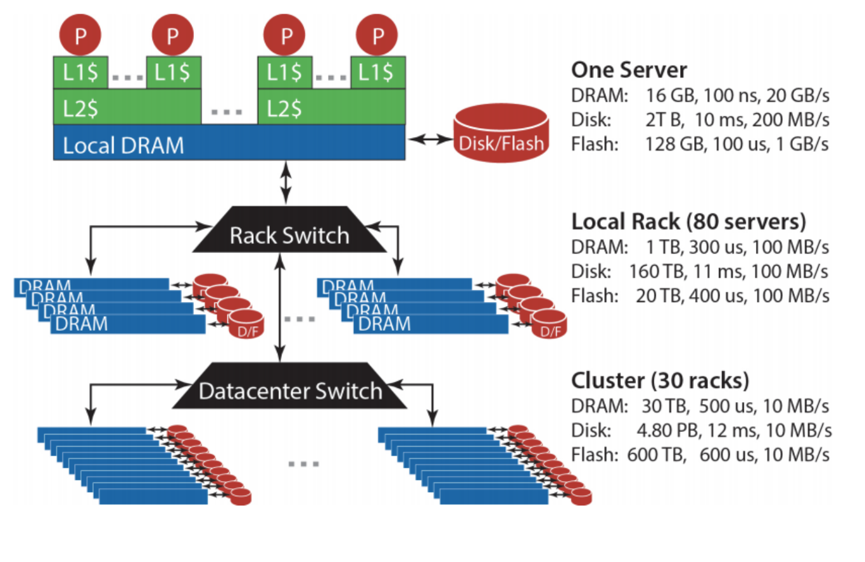

Storage hierarchy:

* memory space increases as we go from Local Server to Rack to Datacenter.
* communication costs increase → latency increases and bandwidth decreases ⇒ sending data further on a network is costly
* latency of P accessing the local disk of the server is similar to that of accessing the disk in other servers in the same rack: The network in the Rack is relatively fast, and the disk performance becomes the bottleneck.

Disk reads are expensive:

* orders of magnitude slower in both Latency and Bandwidth. Latency of local disk reads is even more than from Rack / Datacenter DRAM.
* DRAM is more expensive and limited than disk space, and is also not persistent.
* Thus, for storing massive amounts of data which does not have to be accessed frequently, or for data we want to persist even when the server goes down, using disk is more appropriate

**Bandwidth (e.g. GB/s):** maximum amount of data that can be transmitted per unit time

* how long the transmission will take for large amount of data

**Latency (e.g. ms):** time taken for 1 packet to go from src → dest (one-way) or from src → dest → src (round trip)

* how much delay there will be for small amount of data

**Throughput:** rate at which some data was *actually* transmitted across the network during some period of time

Big ideas of massive data processing in data centers:

1. Scale “out”, not “up”
   * combining many cheaper machines instead of increasing the power of each individual machine
   * aka ’horizontal’ vs ‘vertical’ scaling
2. Move processing to the data
   * Clusters have limited bandwidth → move the task to the machine where the data is stored
3. Process data sequentially, avoid random access
   * Seeks are expensive, disk throughput is reasonable
4. Seamless scalability
   * E.g. If processing a certain dataset takes 100 machine hours, ideal scalability is to use a cluster of 10 machines to do it in about 10 hours.

**Divide and Conquer (Partition-Combine)**

**Challenges:**

1. Machine Failures
2. Synchronisation
   * Make workers as independent as possible
3. Programming Difficulty [Concurrency]
   * Many one-off solutions
   * dedicated library

Datacenter as the computer

* Right level of abstraction
* Hide system-level details from the developers
  + no need to explicitly worry about concurrency, reliability and fault tolerance

Typical big data problem:

1. Iterate over a large number of records
2. Extract something of interest from each [Map]
3. Shuffle and sort intermediate results [Shuffle]
4. Aggregate intermediate results [Reduce]
5. Generate final output

**MapReduce**

Overall idea:

1. Map - for each partition worker nodes create key-value pairs
2. Reduce - all values with the same key are sent to the same reducer

map(k1, v1) → List(k2, v2)

reduce(k2, List(v2)) → List(k3, v3)

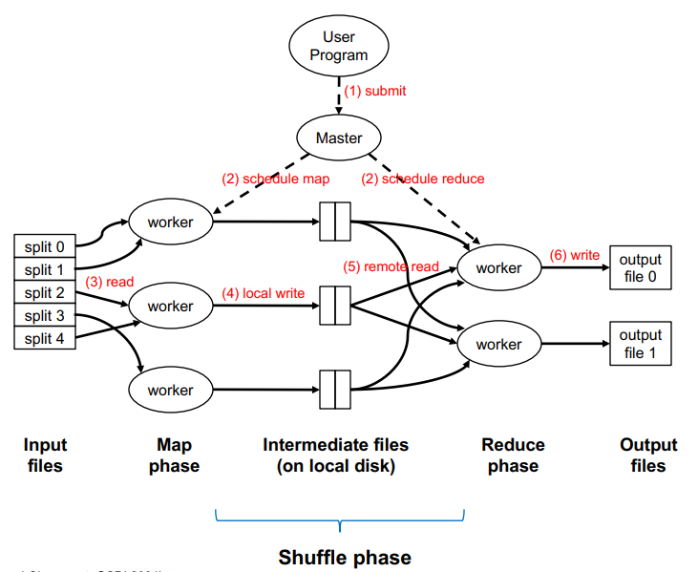

Master node - takes care of scheduling-related details; will not touch data

Map worker nodes

* Can take more than 1 split and map to a key-value pair
* workers write locally to intermediate files on local disk to be shuffled and sent to reduce nodes
* If each split is too large → too little machines used; not effective parallelism
* If each split is too small → overhead is too large

Shuffle stage

* Runs in the worker nodes
* disk & network I/O from mapper to reducers across networks

**Barrier between Map and Reduce phases**

* keys arrive at each reducer in sorted order (similar concept to mergesort)

Reduce worker nodes

* After all processes reach the barrier then reduce worker nodes will start working
* Reduce nodes read data remotely
* Values of same key sent to the same worker node

**Map Task:** basic unit of work (typically 128MB)

* At the beginning, the input is broken into splits of 128MB.
* A map task is a job requiring to process one split; not a physical machine.
* A single physical machine can handle multiple map tasks
* A single map task can involve many calls to map function, e.g. within a split, there will be multiple (k, v) pairs → each produces one call to a map function

**“Mapper” or “Reducer”:** process executing a map/reduce task, not to physical machines.

* # map tasks = # mappers
* E.g. 5 mappers but 3 physical machines
* Arrows from map tasks to workers

**Map function:** A single call to the user-defined map(k1, v1) → List(k2, v2) function

**Optimization (Partition & Combine)**

* Optional optimization to reduce network traffic

**Partition Step**

* By default, assignment of keys to reducers is determined by hash function
* For better division of work; **more even distribution**
  + highly imbalanced partitions may not result in significant improvement
* e.g. key k goes to reducer: (hash(k) mod num_reducers)
* Each reducer handles **all** the keys assigned to it by the partitioner
* Each reducer’s input is **sorted by key**: E.g. if a reducer handles keys A and C, it will be fed key A before key C
* a partitioner can improve performance when some keys are much more common than others.
* Partition scheme is efficient if there are many filter/group by queries based on the partition scheme
  + E.g. e-commerce: partition by no. of products bought by customers

**Combiner Step**

* locally aggregate output from mappers
* Reduce disk writes [Intermediate files]; Combiner happens right after Map()
* ‘Mini-reducers’
* combiner should not affect the correctness of the final output, whether the combiner runs 0, 1, or multiple times
  + Output type same as mapper
  + input type same as reducer
  + correct to use reducers as combiners if the reduction involves a binary operation (e.g. +) that is both associative (a+b)+c = a+(b+c) and commutative a+b = b+a

[Local worker](Map → Combine → Partition) → Shuffle → Reduce

**Performance Guidelines**

**Linear Scalability:** more nodes can do more work at the same time

* Linear on data size
* Linear on computer resources e.g. x2 machine → speed x 2

**Minimise the amount of I/Os**

* Minimise disk I/Os; sequential access vs random access
* Minimise network I/Os; bulk vs many small requests [communication between nodes]

**Memory working set** **of each task/worker**

* large memory working set → high memory requirements / probability of out-of-memory errors

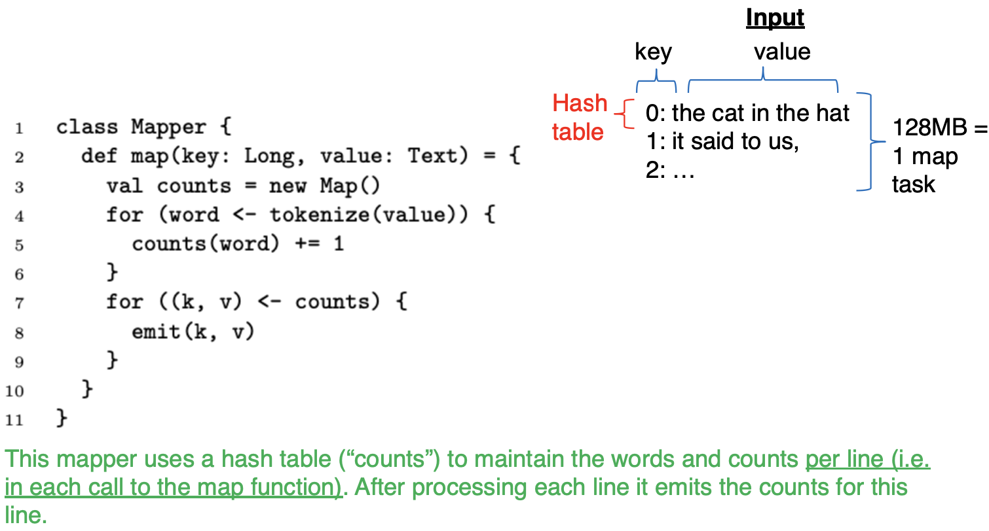

* Not fully aggregating across data; only aggregating per line
* Better to aggregate across lines

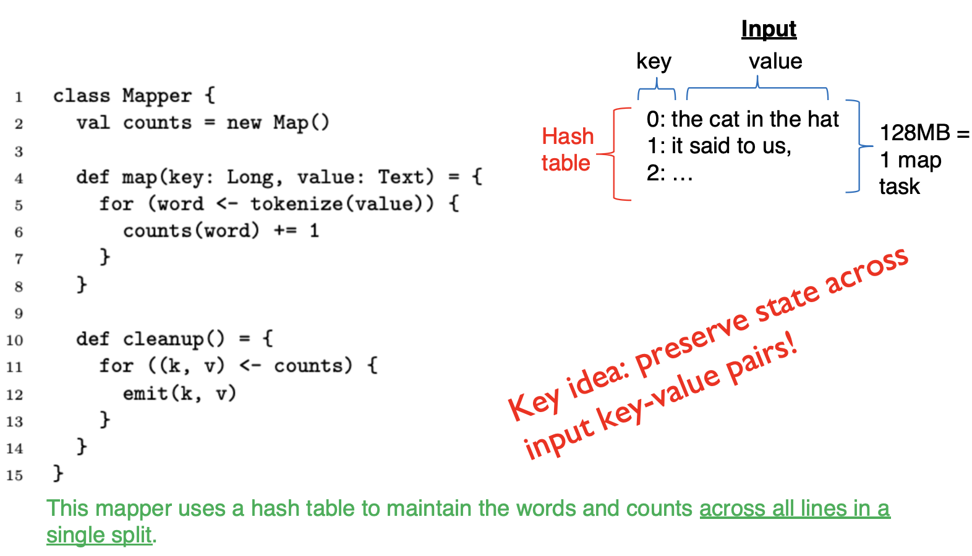

* Will not emit anything until all lines are mapped
* Preserves state across input key-value pairs
* Adv: Reduces network and disk I/O
* Disadv: Increases Memory working set

**Distributed File System**

* Move workers to data: store data on local disks of nodes in the cluster
* Start up the workers on the node that has the local data
* E.g. Google File System (GFS), Hadoop Distributed File System (HDFS)

Assumptions

* Scale out not up
* High component failure
* Modest number of huge files
* Files are write-once, mostly appended to
* Large streaming reads instead of random access → high sustained throughput over low latency

Design decision:

* Files stored as chunks (fixed size: 128MB)
  + Too small: high overhead OR large amount of disk and network I/O
  + Too big: limited parallelism OR cannot fit into memory of individual workers
* Reliability through replication (3+) to tackle high failure rate
  + Replicate more: system will be more robust to node failure but storage overhead and slow write performance
* Single master to coordinate access and keep metadata → centralised mgt

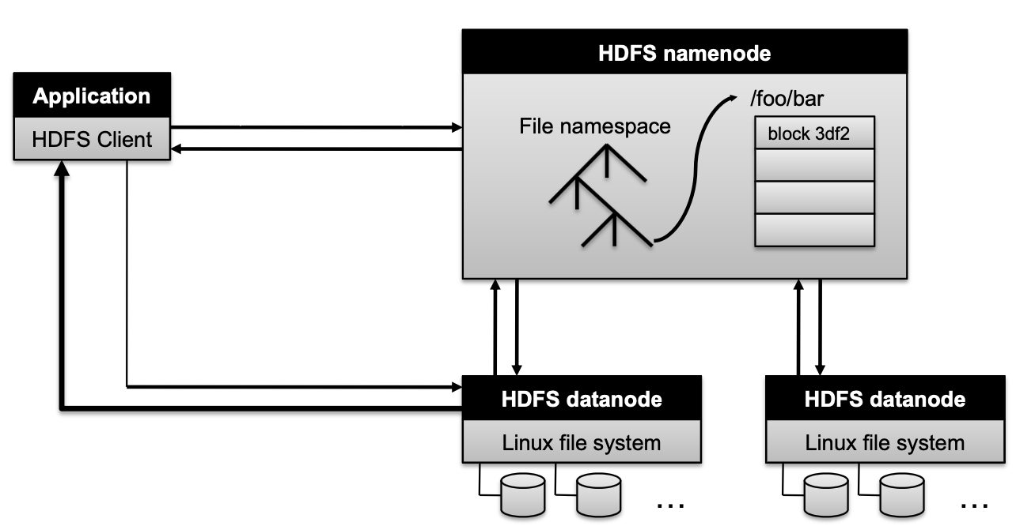

Namenode responsibilities

* decides which datanodes are to be used as replicas. The 1st datanode forwards data blocks to the 1st replica, which forwards them to the 2nd replica, and so on.
* Managing the file system namespace:
  + Holds file/directory structure, metadata, file-to-block mapping, access permissions, etc.
  + Directs clients to datanodes for reads and writes
  + No data is moved through the namenode
* Maintaining overall health:
  + Periodic communication with the datanodes
  + Block re-replication and rebalancing
  + Garbage collection
* If namenode data is lost: All files on the filesystem cannot be retrieved since there is no way to reconstruct them from the raw block data.
  + Mitigations: backups and secondary namenodes

Flow:

1. App sends requests to namenode
2. Namenode searches its directory, thus obtains the list of blocks in this file and where they are stored
3. Namenode directs clients to read the needed blocks from the datanode storing it
4. [For duplication] After writing 1 datanode, the datanode communicates with another data node for replication
   * Namenode decides which datanodes are to be used as replicas
   * datanode-datanode communications

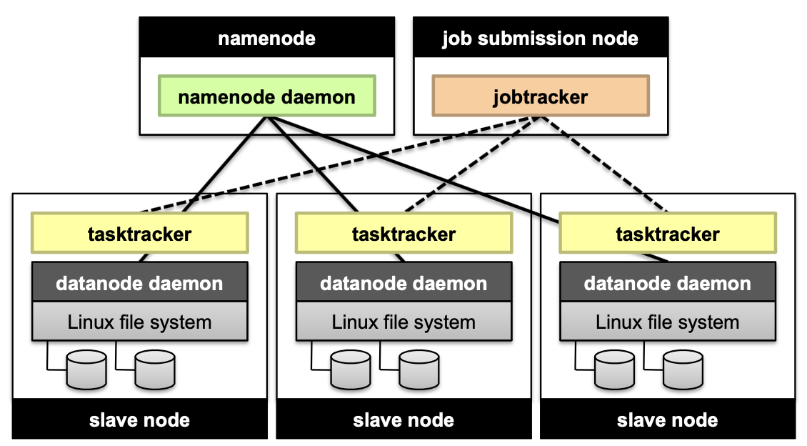

* Job submission node = master node for map reduce: communicate with tracker processes
* Namenode for managing HDFS
* Slave node = worker node for map reduce
* Map reduce will not be done on replicas

**Q: Can a single physical machine handle multiple map tasks, or a combination of map and reduce tasks?**

* Yes. When a machine completes a map task, it can be assigned to another such task.
* Furthermore, machines used for map tasks are often reassigned to reduce tasks once the map phase is done

**Preserving State in Mappers/Reducers**

* 1 map task calls map function multiple times → good to keep track of state over multiple map functions

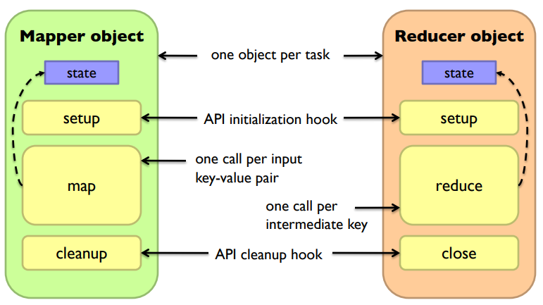

**Secondary Sort**

Issue: Each reducer’s value arrive unsorted but we want it to be sorted

* NOTE: Keys for reducers are sorted but values are not!!

Solution:

* define a new composite key as (K1, K2) where K1 is the original key (natural key) and K2 is the variable we want to use to sort
* Partitioner needs to be customised to be partitioned by K1 **only**

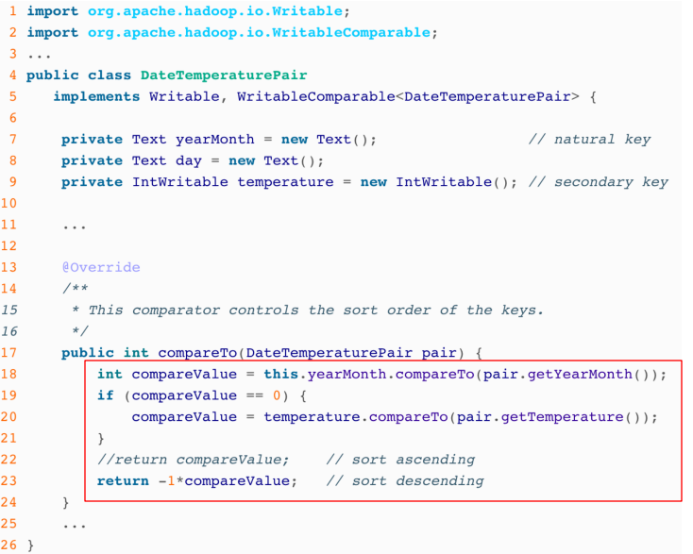

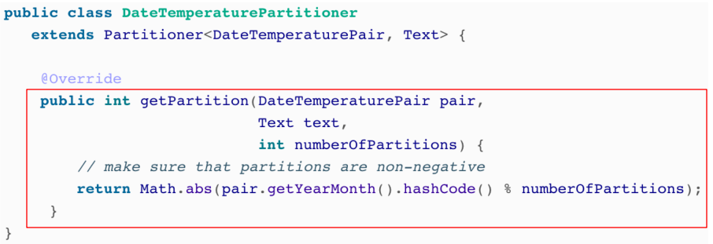

**Relational Databases and MapReduce**

Projection in MapReduce:

* Take a tuple (with tuple ID as key) and emit new tuples with appropriate attributes
* No reducer needed (no shuffle step)

Selection in MapReduce:

* Take a tuple (tuple ID as key) and emit tuples that meet the predicate
* No reducer needed

Group by … Aggregation

* SQL uses GROUP BY function
  + SELECT product_id, AVG(price) FROM sales GROUP BY product_id;
* MapReduce map over tuples and emit <product_id, price>
* Framework automatically groups values by keys
* compute average in reducer & optimised with combiners

Relational joins for MapReduce

Method 1: Broadcast (or ‘Map’) join

* Fit one of the tables in memory → suitable for tables size < 128MB/memory size of 1 mapper
* All mappers store a copy of the small table (for efficiency: convert to a hash table with keys as the keys we want to join by)
* Iterate over the big table and joining the records with the small table

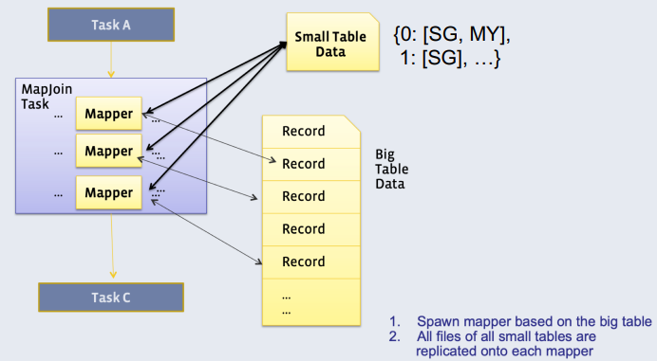

* small data table must be stored on a single computer
* Only map, no reduce
* Adv: No need for shuffle: remove disk and network I/O

Method 2: Reduce-side (‘Common’) join

* Doesn’t require a dataset to fit in memory, but slower than map-side join
* Different mappers operate on each table, and emit records, with key as the variable to join by
* In reducer: we can use secondary sort to ensure that all keys from table X arrive before table Y → hold the keys from table X in memory (more space-efficient but time-consuming) and join them with records from table Y
* Only need to hold the table of a single key in memory

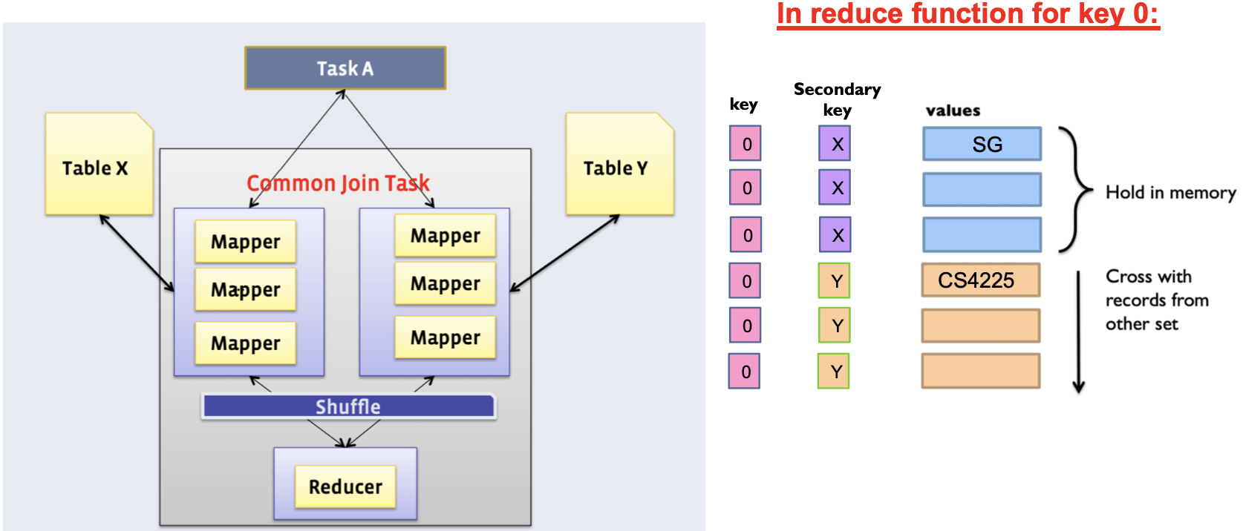

**Similarity Search**

“Near neighbours” as points that are a “small distance” apart → lower distance; higher similarity

Euclidean distance

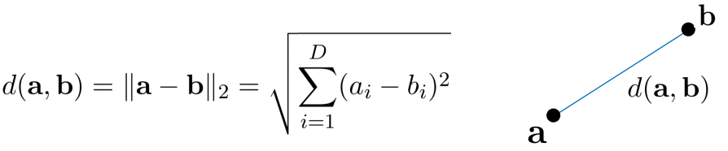

Cosine Similarity

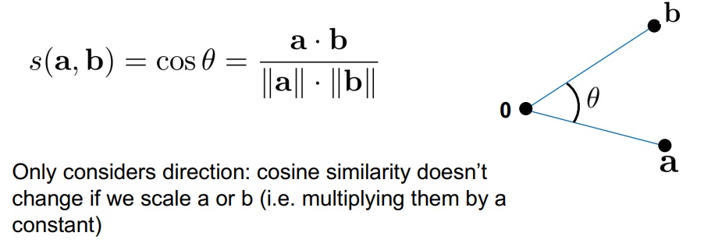

Jaccard Similarity

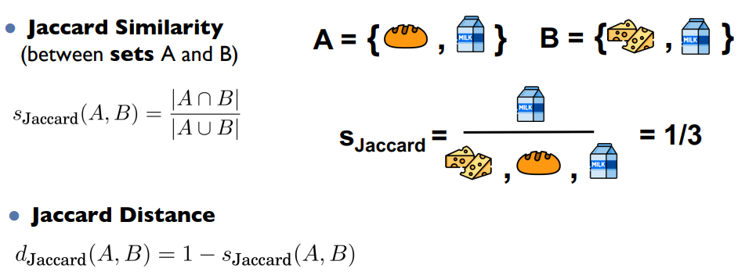

**Task: Finding Similar Documents**

All pairs similarity: Given a large number N of documents, find all “near duplicate” pairs e.g. distance below a threshold

OR

Similarity Search: given a query document D, find all documents which are “near duplicates” with D

**2 steps for Similar Docs**

1. Shingling: Convert documents to sets of short phrases

* A k-shingle: sequence of k tokens that appears in doc, C1
* E.g. k = 2; document D1 = “the cat is glad”
* Set of 2-shingles: S(D1) = {“the cat”, “cat is”, “is glad”}
* Often represented as a matrix, col = D and rows = shingles
* Similarity between docs = Jaccard Similarity

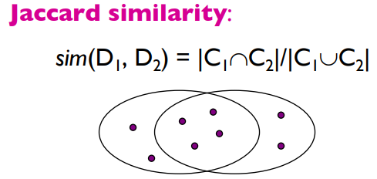

Shingles in D1 & D2 - Total unique shingles in D1 & D2

1. Min-Hashing: Convert large sets to short “signatures” of each document, while preserving similarity [Fast approximation]
   * Signature = hashed data
   * Same signatures = candidate pairs/near duplicates
   * Hash functions are deterministic: same input = same output

* Key idea: hash each column C to a small signature h(C) [C → set of shingles]
  + h(C) is small enough to fit in RAM
  + highly similar docs have the same signature = Jaccard-Sim(C1, C2)
  + If sim(C1, C2) is high → Pr[h(C1) = h(C2)] = high
  + If sim(C1, C2) is low→ Pr[h(C1) =/= h(C2)] = high
* Steps:

1. Given a set of shingles, we have a hash function h that maps each shingle to an integer
2. Compute the minimum of these hashes

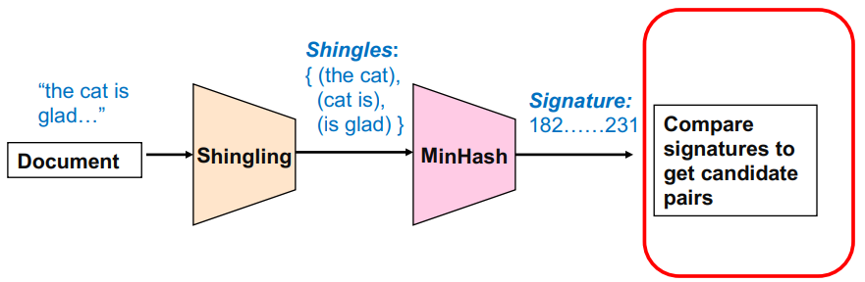

Candidate pairs: docs with the same final signature

Extension to multiple hashes: Reality, uses multiple hash functions (e.g. N = 100) and generate N signatures for each doc.

* Candidate pairs can be redefined as those matching a ‘sufficient number’ e.g. >= 50 among these signatures

**MapReduce Implementation**

Map:

* Read over the document and extract its shingles
* Hash each shingle and take min to get MinHash
* emit<signature, doc_id>

Reduce:

* Receive all documents with a given MinHash signature
* Generate all candidate pairs from these docs
* (Opt.) compare each pair to check if they are similar

**Clustering**

Separates unlabelled data into groups of similar points. Clusters should have high intra-cluster(within clusters) similarity and low inter-cluster similarity (across clusters)

K-means algo:

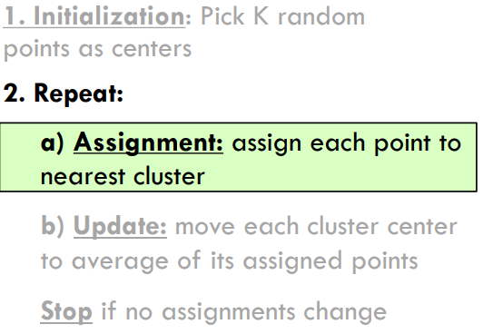

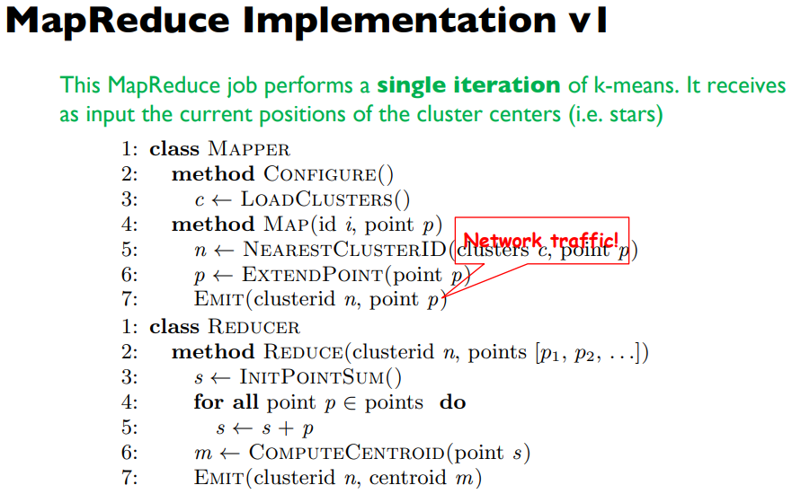

* Each emit transmits O(d)
* After average of clusters change, the rest of the points do not get reassigned to new cluster -> more MapReduce jobs
* O(nmd) [n = no. of points; m = no. of iterations; d = dimensionality e.g. (x, y) = 2d; k = no. of centres]

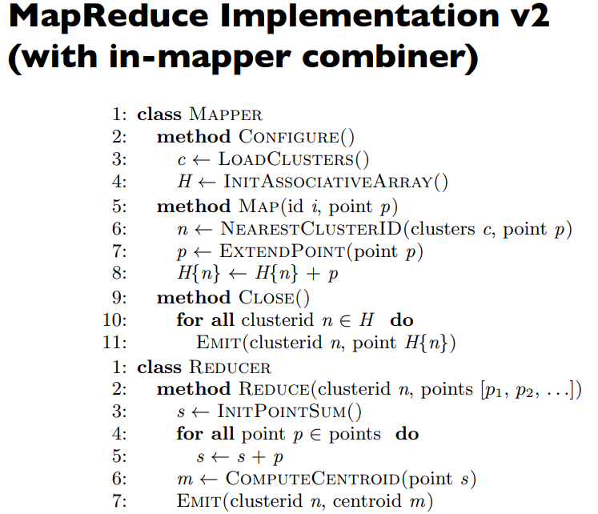

* Combiner: Lines 9-11
* line 8: accumulate for each cluster first
* point H{n} → (sum of coordinates, count) for each centre
* O(kmd)

**NoSQL - Not Only SQL**

Key-Value Stores

Data Model:

* Stores associations between keys and values (keys → simple primitive data)
* Keys are primitives and can be queried
* Values can be primitive/complex

Operations:

* simple API → get(key); put(key, value)
* opt. operations
  + Multi-get
  + Multi-put
  + Range queries
* Suitable for continuous reads & writes
* Storing basic info; or no clear schema
* Complex queries not required (e.g. join)

Examples:

* Storing user sessions
* Caches
* User data that is often processed individually
* Non-persistent: big in-memory hash table
  + Memcached, Redis
* Persistent: Data is stored persistently to disk
  + RocksDB, Dynamo, Riak

Document Stores (MongoDB)

Document Model:

* A database can have multiple collections
* Collections have multiple documents → JSON-like objects

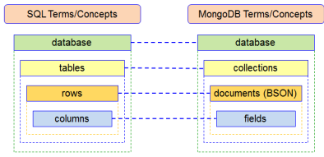

Querying:

* Unlike key-values, can query based on content
* CRUD
* Unlike SQL, no fixed schemas → easy to have inconsistencies

Wide Column Stores

* Rows describe entities
* Related groups of columns are grouped as column families
* Sparsity: if a column is not used for a row → doesn’t use space
* E.g. BigTable, Cassandra, HBase

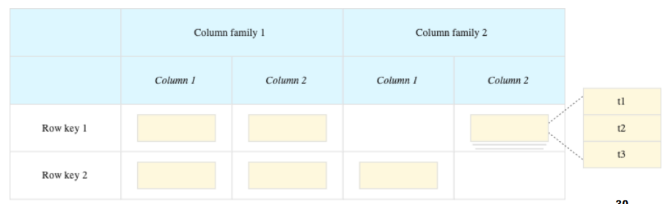

**Strong vs Eventual Consistency**

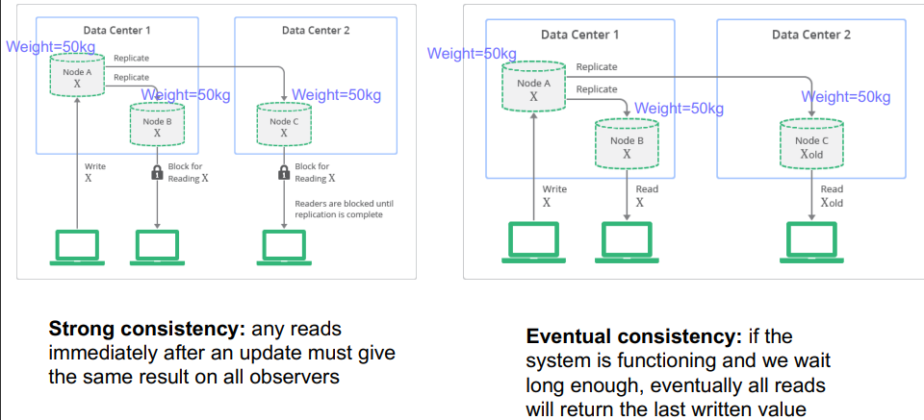

Strong Consistency: Only release after change is fully propagated → slower; need to wait

Eventual Consistency: No need for wait → System returns faster

* update when reading from the original node at the next read!

**SQL provides ACID** guarantees → Atomicity; Consistency; Isolation; Durability

**NoSQL relaxes to BASE**

* Basically Available: basic reading & writing avail most of the time → quick response
* Soft state: Only have some probability of knowing the state at any time → guarantees
* Eventual Consistency

**Duplication**

Solves: joins in NoSQL DBs

* Some later versions of MongoDB do support joins

Motivation:

* Storage is cheap
* NoSQL tables are designed around the queries we expect to receive → no need for joins at all
* Disadvantage: If a field that is present across multiple collections is changed, need to propagate all the documents in all the collections → expensive + need logic on application side to handle

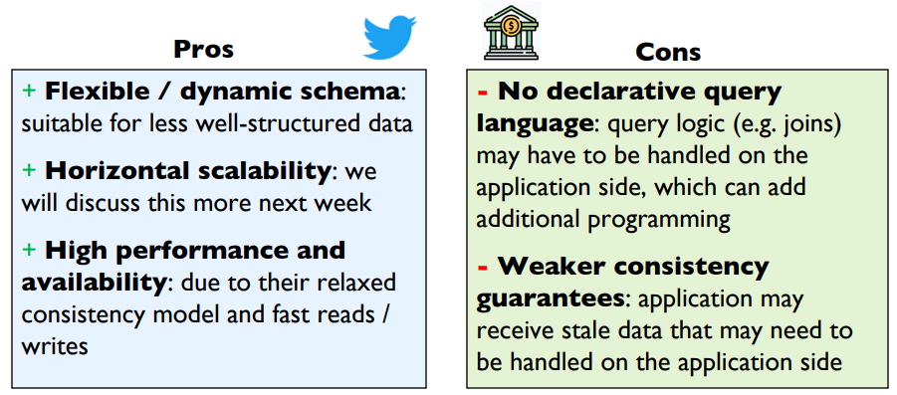

**Distributed Databases**

Assumptions:

1. All nodes in a distributed databases are well-behaved (i.e. no nodes trying to corrupt database)
2. A query that works on a single node database should still work on distributed database

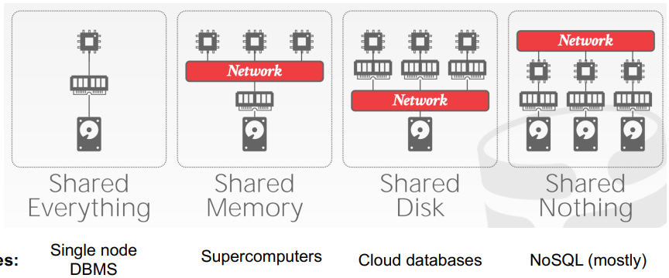

* Cloud DB: Simpler; vertical scaling
* NoSQL: CPUs communicate with each other; horizontally scaling

**Data Partitioning**

Table Partitioning

**Key idea:** Put different tables (or collections) on different machines

**Problem:** scalability → each table cannot be split across multiple machines

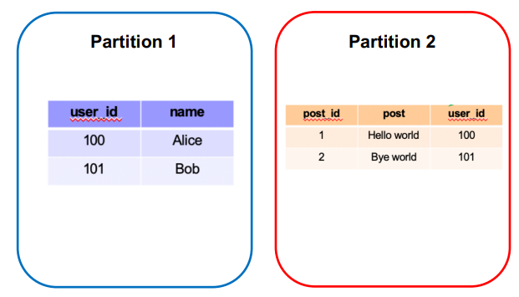

Horizontal Partitioning

**Key idea:** Different tuples are stirred in different nodes a.k.a sharding; separated by partition key

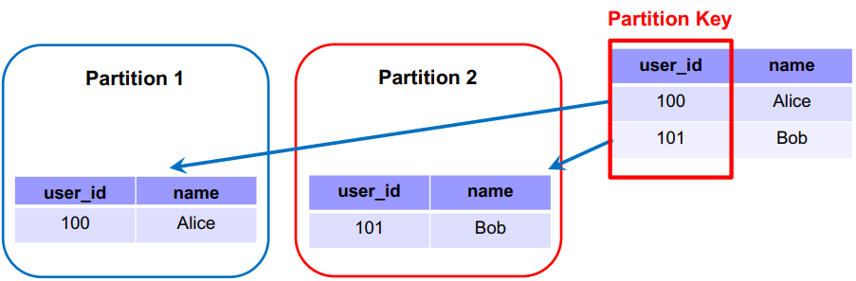

**Partition Key:** variable used to decide which node each tuple will be stored on → same key = same node

* If we often need to filter tuples based on a column or “group by” a column, then that column is a suitable partition key
* Data from other partition can be ignored → **partition pruning**

Horizontal Partition - Range Partitioning

**Key idea:** Different tuples are stored in different nodes → each partition should be similar size

Split partitions key based on range of values

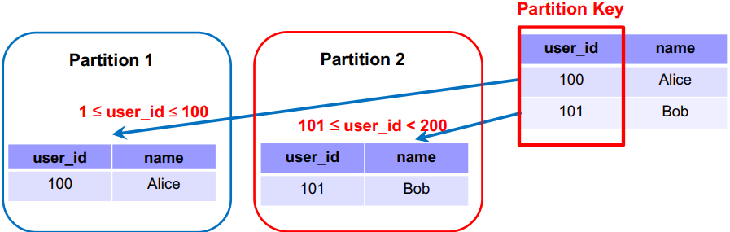

**Advantage:** Good for range-based queries e.g. select user_id < 50 then data in partition 2 can be ignored (partition pruning)

**Disadvantage:** Imbalance shards → needs a balancer so if range expands too much can rebalance

Horizontal Partitioning - Hash Partition

**Key idea:** Different tuples on different nodes; hash partition key then divide that into partitions based on ranges

* Hash function automatically spreads out partition key values roughly evenly
* Requires consistent hashing to ensure minimum data to be moved around

**Consistent Hashing**

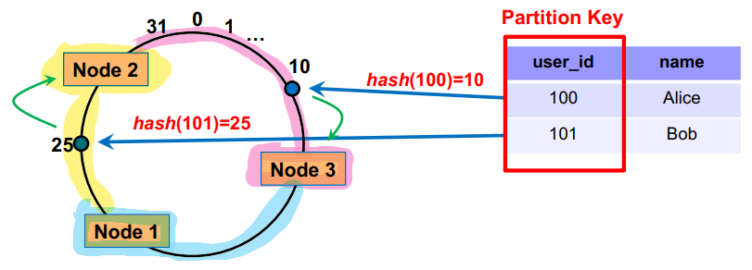

Each tuple is placed on the circle, and assigned to the node that comes clockwise-after it

Delete a node:

Re-assign all tuples to the node clockwise after it e.g. delete node 3; all tuples on node 3 re-assigned to node 1

Add node:

Split the largest current node into 2

Replication strategy:

Replicate a tuple in the next few additional nodes clockwise after the primary node used to store it

E.g. 10 on node 3 → replicated on node 1 & 2 if “next few” = 2

→ replicated on node 1 if “next few” = 1

Optimization - Multiple Markers per node:

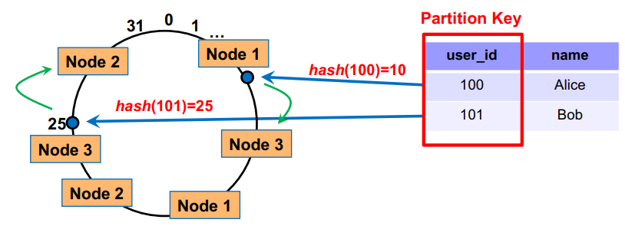

Assign marker nearest to it in the clockwise direction

**Advantage:** If a node is removed, its tuples will not all be reassigned to the same node → better load balancing!

**Architecture of MongoDB**

* 1 shard not necessarily = 1 machine
* If primary shard goes down secondary shard promoted
* In above diagram, 1 shard = 3 machines

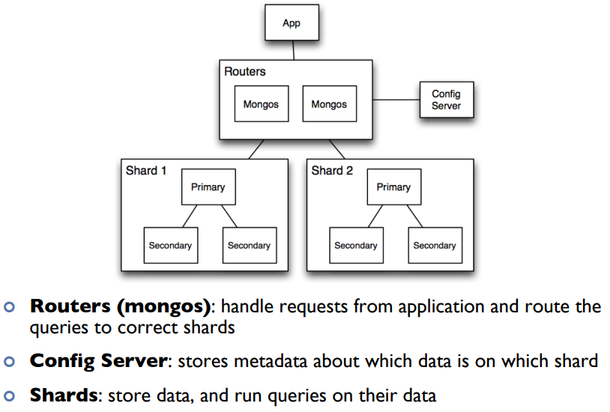

Read/Write flow:

1. Query is issued to a router (mongos) instance
2. With help of the config server, mongos determines which shards should be queried
3. Query is sent to relevant shards
4. Shards run queries on their data, and send results back to mongos
5. mongos merges the query results and returns the merged results

**Scalability and Performance of NoSQL**

Horizontal Partitioning:

* More data → partitions into more shards
* improves speed due to parallelization as each shard runs independently of each other

Duplication:

* Using duplication allows NoSQL queries to only go up to 1 collection

Relaxed consistencies guarantees

* prioritises availability over consistency → returns slightly stale data
* But much faster and Basically Available at any time

Reasons for slow Hadoop performance

* One server: Hadoop incurs significant performance slowdowns due to disk I/O and network I/O (during the shuffle phase, we have to write data to disk and also send it across the network from mappers to reducers)
* Multiple servers:
  + Some clusters can be huge (e.g. containing the majority of the data points), which results in limited benefits of parallelism during the reduce stage (since the points in each cluster are only handled by 1 worker).
  + The bottleneck may be the latency of reading and writing from HDFS (e.g. consider the case where the data size is small). As such, increasing the number of workers does not improve efficiency.

Tutorial 1

Compute mean of all integers with same key

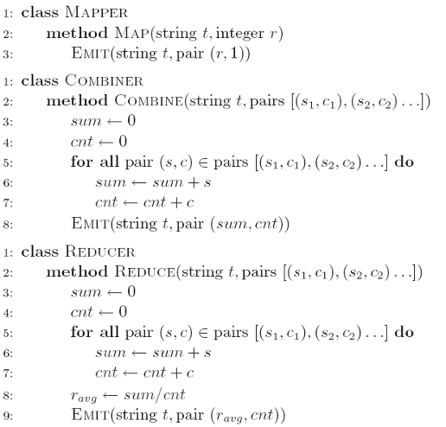

More efficient:

* Partial sum and counts associated with t held in memory across k-v pairs
* CLOSE: emitted only after the entire input split has been processed

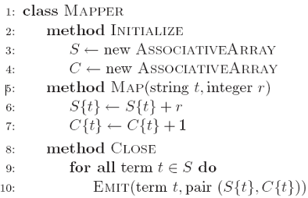

**Lecture 7 - Spark**

Hadoop Mapreduce:

* Network and disk I/O costs: intermediate data (between map & reduce) has to be written to local disks and shuffled across machines, which is slow (overhead from RW to HDFS between jobs)
* Not suitable for iterative (i.e. modifying small amounts of data repeatedly) processing, such as interactive workflows, as each individual step has to be modelled as a MapReduce job.
* More suitable for batch jobs. Designed to handle batch jobs efficiently, process a batch of data per MapReduce job
* Hadoop is cheaper

Spark:

* Less scalable since relies on memory
* stores most of its intermediate results in memory, making it much faster, especially for iterative processing
  + Memory capacity is much more limited than disk → duplicating data is expensive
  + Does not use replication for fault tolerance
* When memory is insufficient, Spark spills to disk → requires disk I/O

**Spark Architecture**

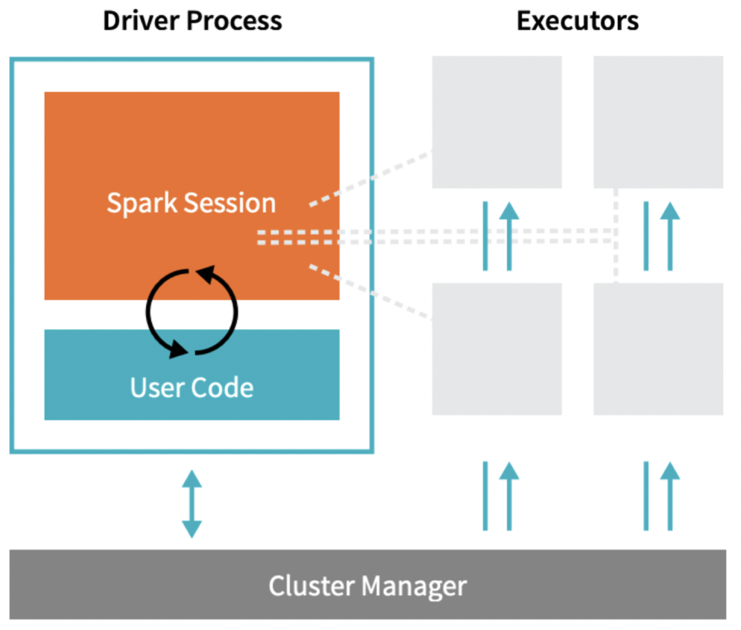

* Driver Process [master node] responds to user input, manages the Spark application etc., and distributes work to Executors (worker nodes for actual computation), which run the code assigned to them and send the results back to the driver
  + Contains all info about current session
  + Manages overall running of the prog
  + Similar to driver code in Hadoop
* Cluster Manager (can be Spark’s standalone cluster manager, YARN, Mesos or Kubernetes) allocates resources (to processes) when the application requests it
  + Responsible for distributing the workload
* In local mode, all these processes run on the same machine

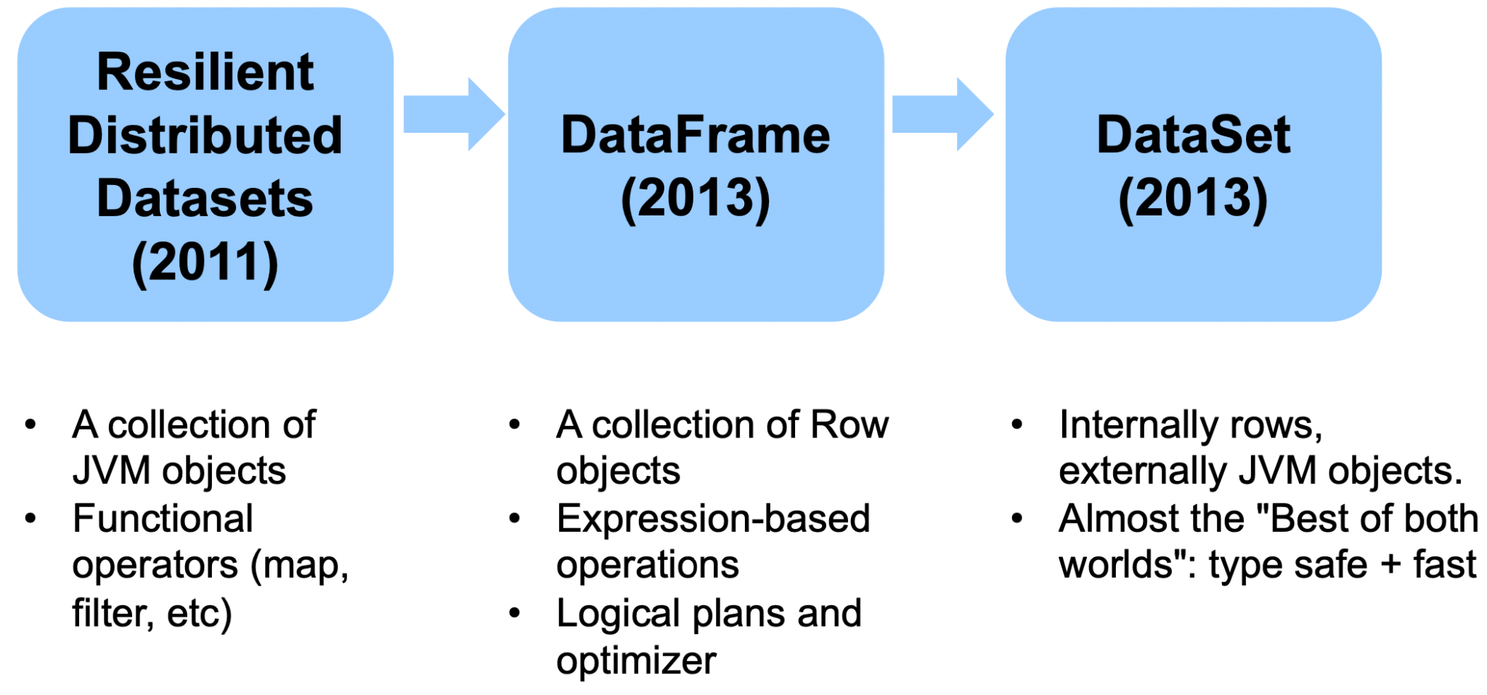

* Dataframe is built on RDD, not type safe
  + Similar to SQL
* Dataset is not available in python
  + type safe → prevent compile time errors

Resilient Distributed Datasets (RDDs)

* R: achieve fault tolerance through lineages
* DD: represents a collection of objects that are distributed over machines
* Immutable
  + cannot change once created
  + Create a new one if modified
* Transformations and actions are executed in parallel → results are only sent to the driver in the final step (after action is executed)

# Create an RDD of names, distributed over 3

Partitions (workers)

# sc: spark context

dataRDD = sc.parallelize(["Alice", "Bob", "Carol", "Daniel"], 3)

* Partition these 4 strings to 3 workers

Transformations (Input: RDD → Output: RDD)

* Transformations are lazy: will not execute until an action is called on it
  + Spark can optimise the query plan to improve speed (e.g. removing unneeded operations)
* Transformation functions can take in either strings or column objects (column name)
* Happens on **worker nodes**
* E.g. map, order, groupBy, filter, join, select
* E.g. nameLen = dataRDD.map(lambda s: len(s))

Actions

* Trigger computation from transformations → only call map when collect() is called
* Involves sending data from Executor to the driver (master node) → slow
* E.g. show, count, save, collect
* E.g. nameLen.collect(): retrieve all elements of the RDD to the driver node
  + Output based on previous section code: [5, 3, 5, 6]

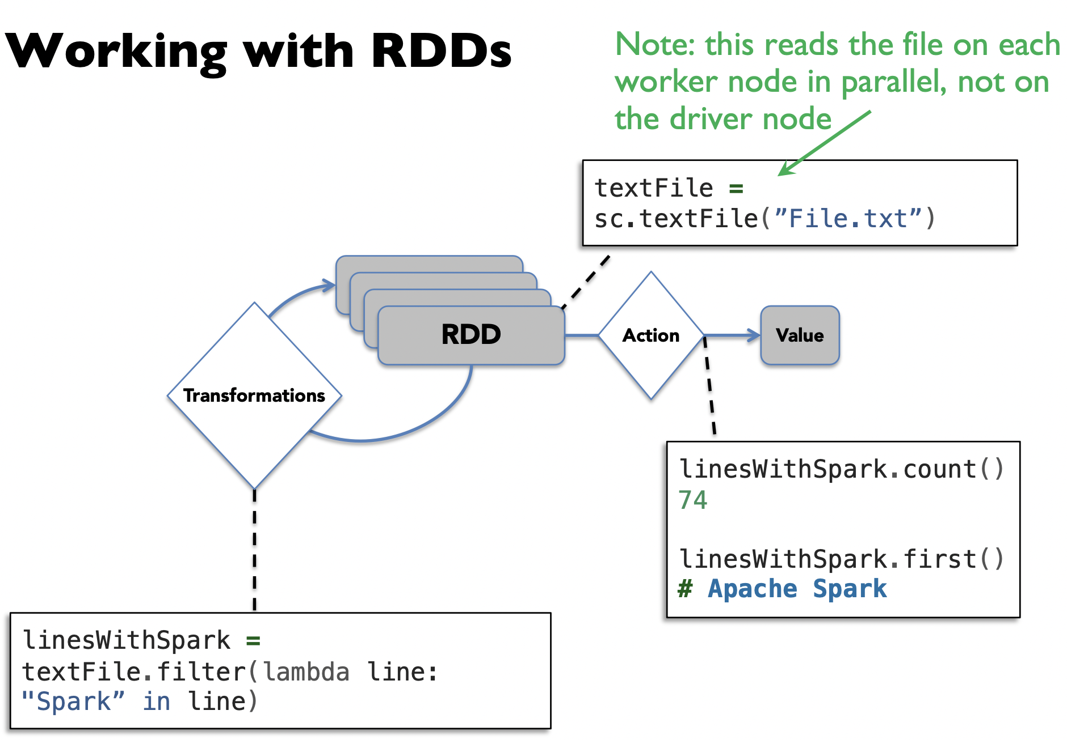

Caching

* cache(): saves an RDD to memory of each worker node
  + Faster but limited to working memory size
* persist(options): can be used to save an RDD to memory, disk, or off-heap memory
  + Options include MEMORY_ONLY, DISK_ONLY, MEMORY_AND_DISK (and others)
  + persist(MEMORY_ONLY) is the same as cache()
  + cache() and persist() are lazy, but not considered transformations
* After data is cached on each worker node, if cached data is transformed again just process cache
* Cache when it’s expensive to compute and needs to be reused
* If worker nodes have not enough memory, they will evict the LRU RDDs
* Spark’s operators spill data to disk if it does not fit in memory, allowing it to run well on any sized data
* Similarly, if there is not enough memory to cache an RDD, it will be ignored & recomputed on the fly (MEMORY_ONLY). If using persist(), the option ‘MEMORY_AND_DISK’ will store it in disk

lines = sc.textFile(“hdfs://...”)

errors = lines.filter(lambda s: s.startswith(“ERROR”))

messages = errors.map(lambda s: s.split(“\t”)[2])

messages.cache()

messages.filter(lambda s: “mysql” in s).count()

messages.filter(lambda s: “php” in s).count()

1. Driver distributes tasks to each worker
2. Each worker reads from HDFS block in parallel
3. Each worker processes and caches data in their own node (no need read from HDFS - hard disk)
4. Workers send results back
5. Next filter gets messages from cache to process

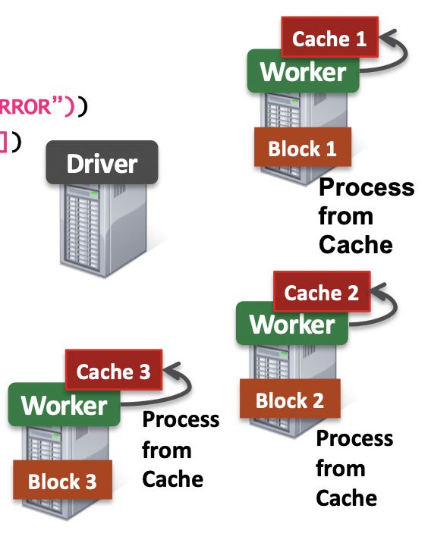

Directed Acyclic Graph (DAG) → Fault Tolerance

* Spark creates DAG to represent all the RDD objects and how they will be transformed
* Action will trigger the transformations
* **Lineage approach for fault tolerance:** if a worker node goes down, replace with a new node and use DAG to recompute the data in the lost partition [only recompute the data in the partition lost → more efficient]
  + If intermediate result stored on a machine disk and disk is still working fine → just recover data from disk
* E.g. WordCount with Spark:

file = sc.textFile(“hdfs://...”)

counts = file.flatMap(line => line.split(“ ”)).map(word => (word, 1)).reduceByKey(_ + _)

counts.save(“...”)

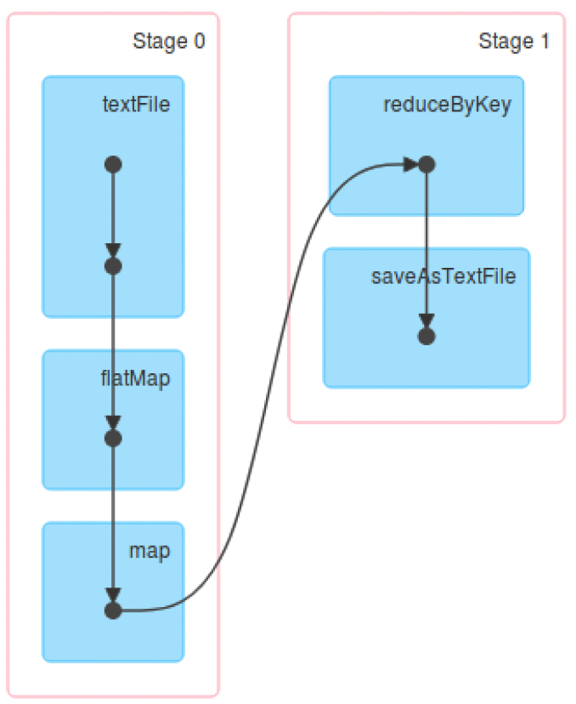

Narrow & Wide Dependencies (Transformation types)

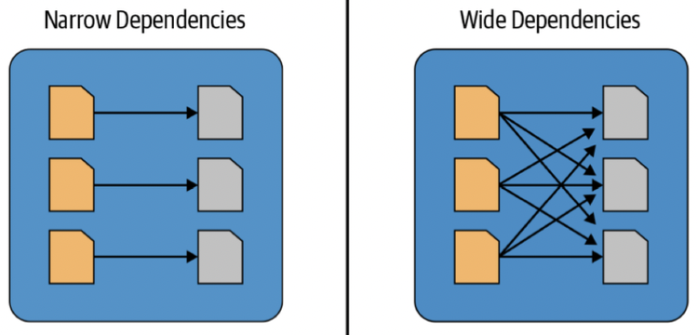

* **Narrow dependencies [local]:** each partition of the parent RDD is used by at most 1 partition of the child RDD
  + Data NOT required to be exchanged across diff partitions
  + Data is processed locally (in-memory) → fast
  + Fast and can run in parallel
  + E.g. map, flatMap, filter, contains, mapPartition, sample, union
  + (called pipelining?)
* **Wide dependencies:** each partition of parent RDD is used by multiple partitions of the child RDD → writes result back to disk
  + Data needs to be exchanged across diff partitions (shuffled) → slow
  + E.g. reduceByKey, groupBy, orderBy, intersection, distinct, join, cartesian, repartition, coalesce
* In the DAG, consecutive narrow dependencies are grouped together as “stages”.
  + E.g. flatMap and map in WordCount
* **Within stages**, Spark performs consecutive transformations on the same machines.
* **Across stages**, data needs to be shuffled, i.e. exchanged across partitions, in a process very similar to map-reduce, which involves writing intermediate results to disk
  + Slow: disk and network I/O
  + Minimizing shuffling is good practice for improving performance.
* Stage boundary: Spark writes intermediate results to the disk (instead of memory)
  + Resilience to failure
  + Reduce memory usage

Why not use duplication like Hadoop?

* Spark tries to store all the data in memory, not disk. Memory capacity is limited so simply duplicating all data is expensive.

Dataframes (recommended interface)

* A DataFrame represents a table of data, similar to tables in SQL, or DataFrames in pandas.
* Compared to RDDs, this is a higher-level and easier-to-use interface,
  + e.g. it has transformations that resemble SQL operations, in fact can use SQL queries by calling x.sql(<normal select query>)...
* all DataFrame operations are compiled down to RDD operations by Spark.
  + Dataframe is just an abstraction over RDDs

E.g.

# reads a DF from a CSV file and creates new DF

flightData2015 = spark\

.read\

.option("inferSchema", "true")\

.option("header", "true")\ .csv("/mnt/defg/flight-data/csv/2015-summary.csv")

# sort by count and output first 3 rows

flightData2015.sort("count").take(3)

* sort is also a transformation

# SQL

flightData2015.createOrReplaceTempView("flight_data_2015")

maxSql = spark.sql("""

SELECT DEST_COUNTRY_NAME, sum(count) as destination_total

FROM flight_data_2015

GROUP BY DEST_COUNTRY_NAME

ORDER BY sum(count) DESC

LIMIT 5""")

maxSql.collect()

* spark.sql(...) is a transformation

# DF Interface

from pyspark.sql.functions import desc

flightData2015\

.groupBy("DEST_COUNTRY_NAME")\

.sum("count")\

.withColumnRenamed("sum(count)", "destination_total")\

.sort(desc("destination_total"))\

.limit(5)\

.collect()

Datasets (DF[Row] but typesafe)

* DataFrame is a subset of DataSet
* Not available in Python and R (not type safe)

case class Flight(DEST_COUNTRY_NAME: String,

ORIGIN_COUNTRY_NAME: String, count: BigInt)

val flightsDF = spark.read.parquet("/mnt/defg/flight-

data/parquet/2010-summary.parquet/")

val flights = flightsDF.as[Flight]

flights.collect()

* collect() returns objects of Flight class, instead of rows

**Lecture 8 - Spark MLLib**

Problem Setup

Classification:

* Categorise samples into classes, given training data
* Test Data and Training Data are different sets of patients!
* E.g. label: positive/negative (1/0) test result → correct answers
* Each row: patient
* Each col: temp, blood pressure etc

Regression:

* predict numeric labels, given training data
* E.g. Response: arbitrary numerical values instead of discrete variable (1/0)

**ML Pipeline:**

1. Preprocessing
2. Training
3. Testing
4. Evaluation

**1. Preprocessing**

* Improve data quality
* Normalisation
* Remove missing values

Data quality

Reasons for missing values

* **­Information was not collected**: e.g. people decline to give weight
* **­Missing at random**: missing values are randomly distributed.
* **Missing not at random:** the missingness itself may be important information.

Handling missing values

* ­Eliminate objects (rows) with missing values ­
  + Suitable if there are small number of missing values
* Or: fill in the missing values ("imputation")
  + ­E.g. based on the **mean/median** of that attribute OR by fitting a **regression model** to predict that attribute given other attributes
  + **Dummy variables:** optionally insert a column which is 1 if the variable was missing, and 0 otherwise
    - Suitable for missing not at random as it can preserve the info of the missing value

imputer = Imputer(inputCols=["a", "b"],

outputCols=["out_a", "out_b"])

model = imputer.fit(df)

model.transform(df).show()

* outputCols = col with missing/null values filled according to the mean (default) / median / regression of remaining values

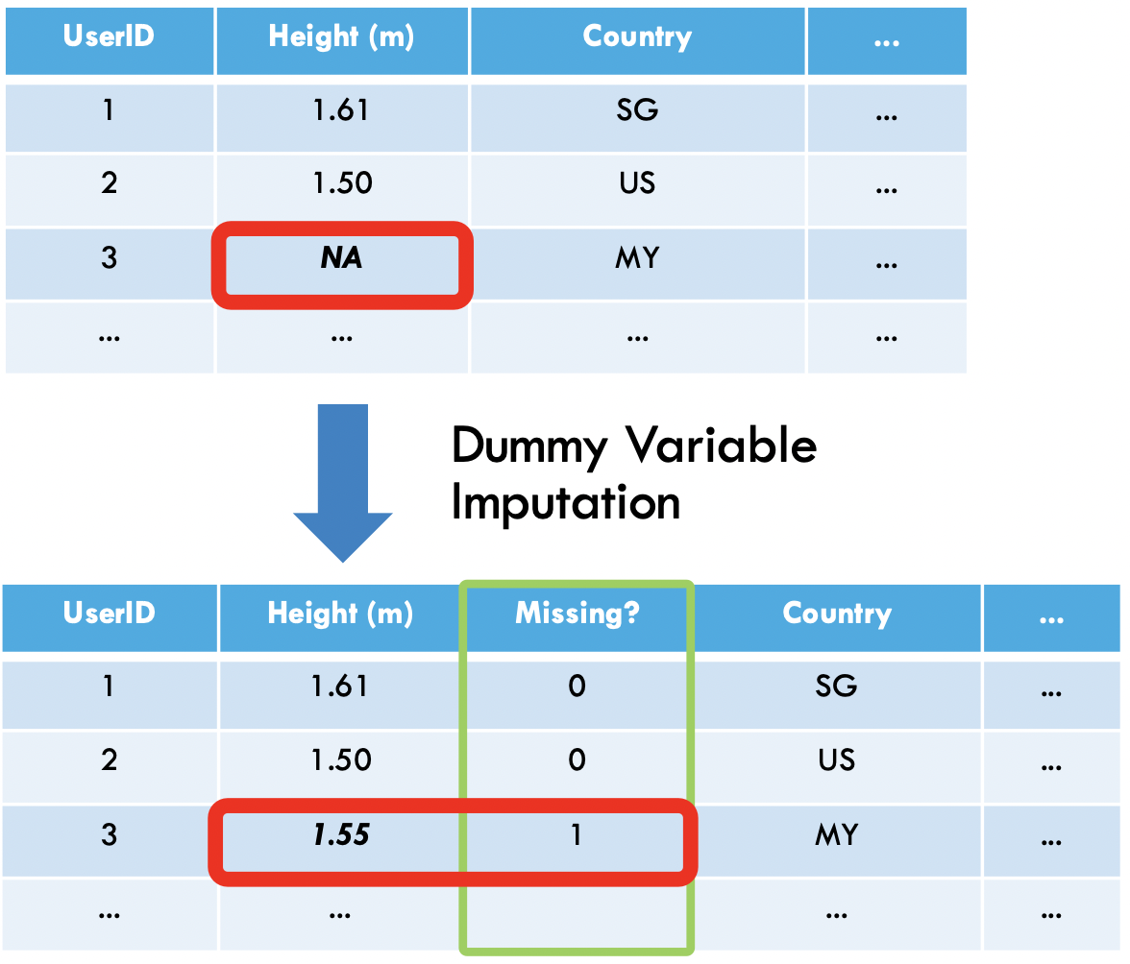

One Hot Encoding

* Convert discrete features to a series of binary features.
* E.g. The first record has group 2, so we set its 2nd binary feature to 1, and all the rest to 0.
* Allows algorithms which can handle binary features (e.g. linear regression) to be applied

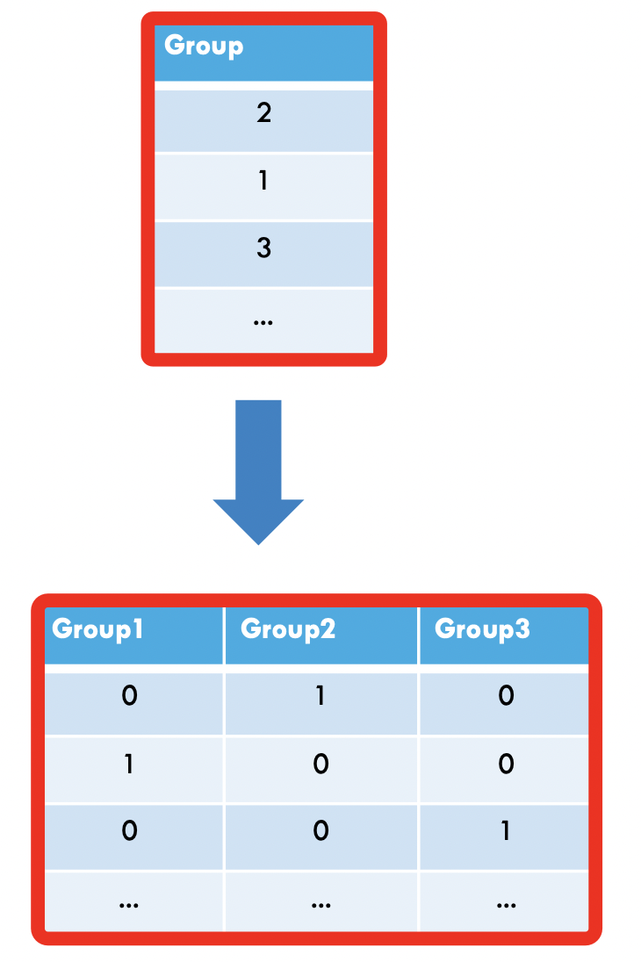 

**Spark MLLib**

from pyspark.ml.classification import LogisticRegression

training = spark.read.format(“libsvm”)

.load(“data/mllib/sample_libsvm_data.txt)

// maxIter: how many steps to train

// lr: estimator

lr = LogisticRegression(maxIter=10)

// lrModel: transformer

lrModel = lr.fit(training)

print(“Coefficients: “ + str(lrModel.coefficients)) // weight

print(“Intercept: “ + str(lrModel.intercept)) // bias

**Pipelines**

* building complex pipeline out of simple building blocks
* e.g. normalization, feature transformation, model fitting.
* Better code reuse: e.g. between the training and test pipelines, cross-validation, model variants, etc.
* Easier to perform cross-validation (use pre-existing spark functions), and hyperparameter tuning.

**Transformers (pentagon symbols)**

* mapping DataFrames to DataFrames (DF)
* E.g. one-hot encoding, tokenization
* Transformer object has a transform() method, which performs its transformation
* transformers output a new DF with result appended to original DF
  + e.g., a fitted model (e.g. logistic regression) is a Transformer that transforms a DF into one with the predictions appended.

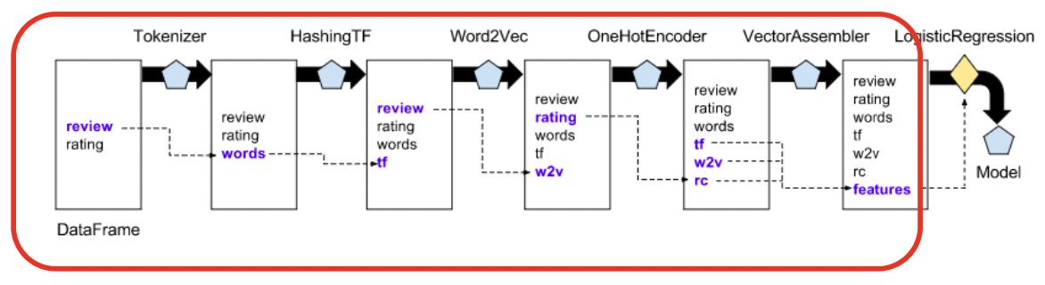

* 1 transformer = 1 pre-processing step
* Old columns are normally preserved across transformations e.g. review and rating in 1st step preserved in second step

**Estimator (diamond symbol)**

* an algo which takes in data, and outputs a fitted model.
* E.g. a learning algo (the LogisticRegression object) can be fit to data, producing the trained logistic regression model.
* have a fit() method, which returns a Transformer. → specific method for estimator

**Pipeline: Training Time**

* A pipeline chains together multiple Transformers and Estimators to form an ML workflow
* Pipeline is an estimator.
* When Pipeline.fit() is called:
  + Starting from the beginning of the pipeline
  + Transformer calls transform()
  + Estimators calls fit() to fit the data, then transform() on the fitted model

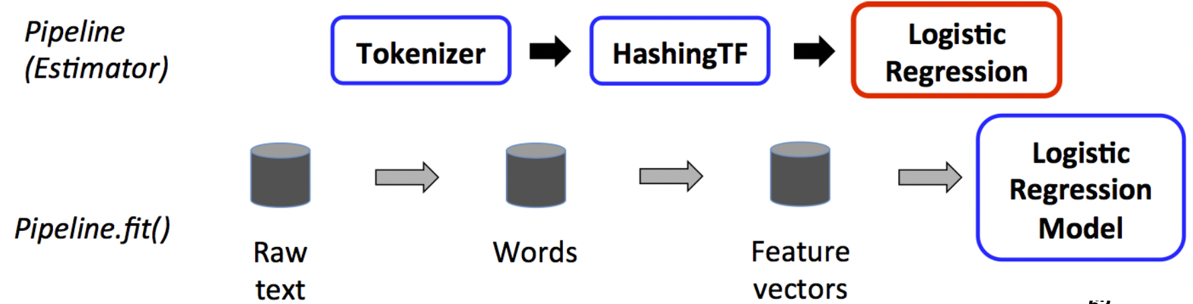

**Pipeline: Test Time**

* output of Pipeline.fit() is the estimated pipeline model (of type PipelineModel).
  + estimated pipeline model is a transformer, and consists of a series of Transformers.
  + When its transform() is called, each stage’s transform() method is called.
* Logistic Regression Model.tranform() return predictions

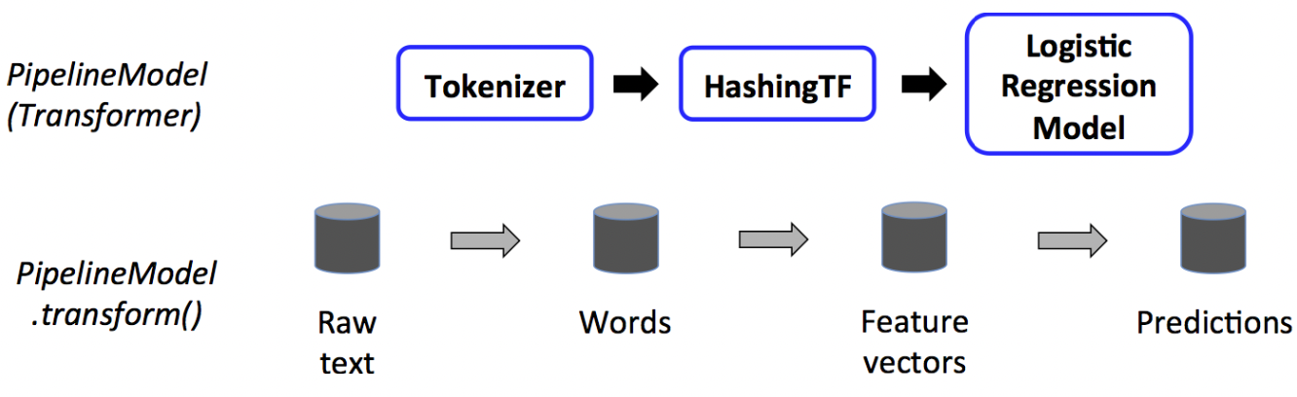

* Tokenizer and HashingTF are Transformers
* Logistic Regression is an Estimator
* To use ML, call Logistic Regression Model (a transformer) to transform the dataset

**Example of Pipeline**

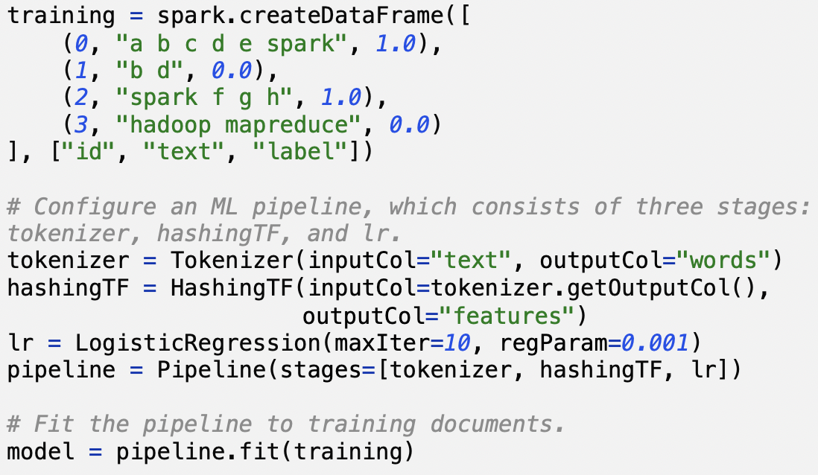

**Lecture 8 - Structured Streaming**

**Traditional Model (record-at-a-time)**

* very low latencies (e.g. milliseconds)
* not very efficient at recovering from
  + node failures
  + straggler nodes (slower nodes)

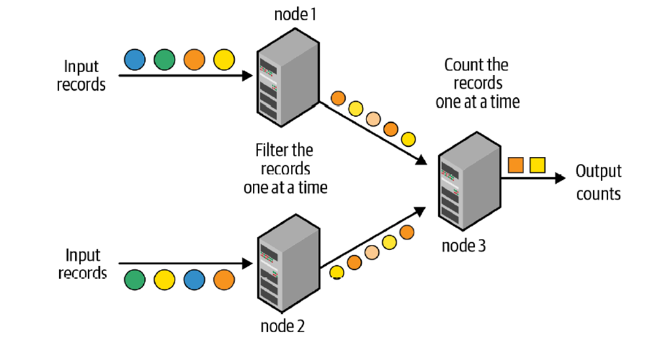

**Micro-Batch Stream Processing (Spark’s Stuctured Streaming)**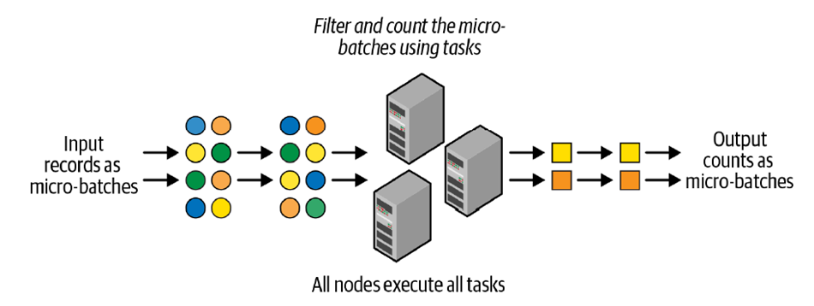

1. divides the data from the input stream into micro batches
2. each batch is processed in the Spark cluster in a distributed manner
3. small deterministic tasks generate the output in micro-batches

* Advantages over traditional model
  + quickly and efficiently recover from failures and straggler executors
  + deterministic nature ensures end-to-end exactly-once processing guarantees
* Disadvantages: latencies of a few seconds
  + OK for many applications
  + Application may incur more than a few seconds delay in other parts of pipeline

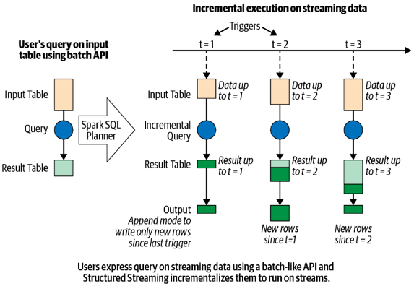

**Defining a Streaming Query**

1. Define input sources
2. Transform data
3. Define output sink and output mode
   1. Output writing details (where and how to write the output)
   2. Processing details (how to process data and how to recover from failures)
4. Specify processing details
   1. Triggering details: when to trigger the discovery and processing of newly available streaming data.
   2. Checkpoint Location: store the streaming query process info for failure recovery
5. Start the query

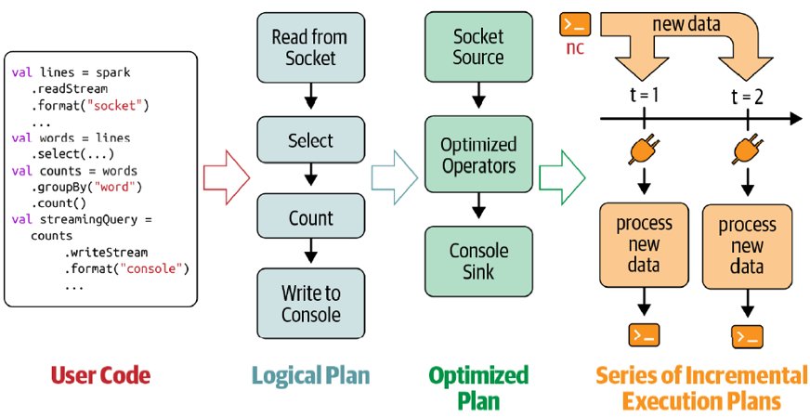

**Data Transformation**

**Stateless Transformation**

* Process each row individually without needing any information from previous rows
* Projection operations: select(), explode(), map(), flatMap()
* Selection operations: filter(), where()

**Stateful Transformation**

* e.g.: DataFrame.groupBy().count()
* In every micro-batch, the incremental plan adds the count of new records to the previous count generated by the previous micro-batch.
* The partial count communicated between plans is the state.
* The state is maintained in the memory of the Spark executors and is **checkpointed** to the configured location to tolerate failures.

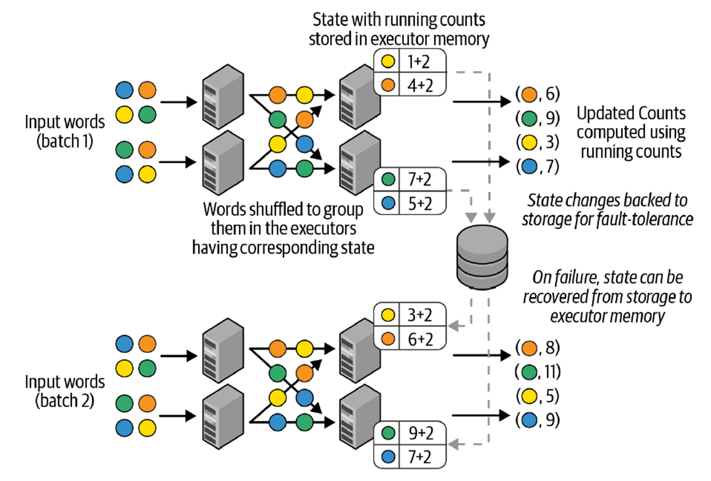

**Stateful Aggregations with Event-Time Windows**

Handling late data with watermarks:

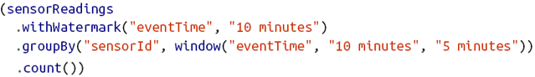

Watermark: do not process too long ago data.

Take the most recent data’s time (e.g. 12:08).

Windows before 12:08-5min=12:03 will not be updated.

**Performance Tuning**

* Cluster resource provisioning appropriately to run 24/7
* Number of partitions for shuffles to be set much lower than batch queries
* Setting source rate limits for stability
* Multiple streaming queries in the same Spark application

**Lecture 9: Graphs & PageRanks**

Web as a directed graph:

* Nodes: webpages
* Edges: hyperlinks

Links as votes:

* In-link: other pages refer to this page
* Out-link: this page refers to other pages
* More in-links → more important pages
* Self-loops are handled just like normal edges
* malicious user can create a huge number of ‘dummy' web pages, to link to their one page, to drive up its rank
* make the number of ‘votes’ that a page has proportional to its own importance.
  + ‘dummy’ pages themselves have low importance → little vote contribution

**Simplified PageRank (NO teleport)**

* Each link’s vote is proportional to the importance of its source page
* For each page j, define its importance/rank as rj
* If page j with importance rj has n out-links, each link gets rj/n votes

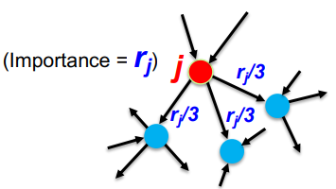

**The Flow Model**

* Page j’s own importance is the sum of the votes on its in-link

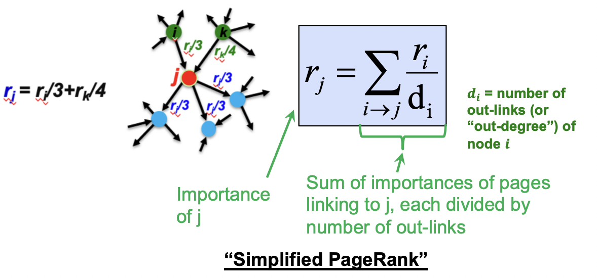

Solving SIMULTANEOUS Flow Equations

* Stochastic adjacency matrix M
  + page i has di out-links
  + If i → j, then Mji = 1/di  else Mji = 0
  + Column stochastic: Columns sum to 1
* Rank vector r: vector with an entry per page
  + ri is the importance score of page i
  + sum of all r = 1

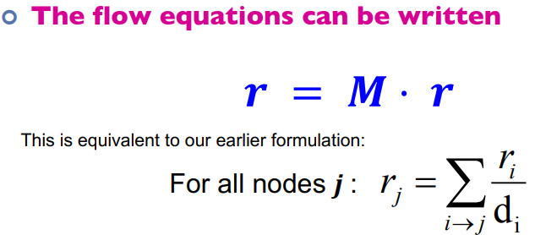

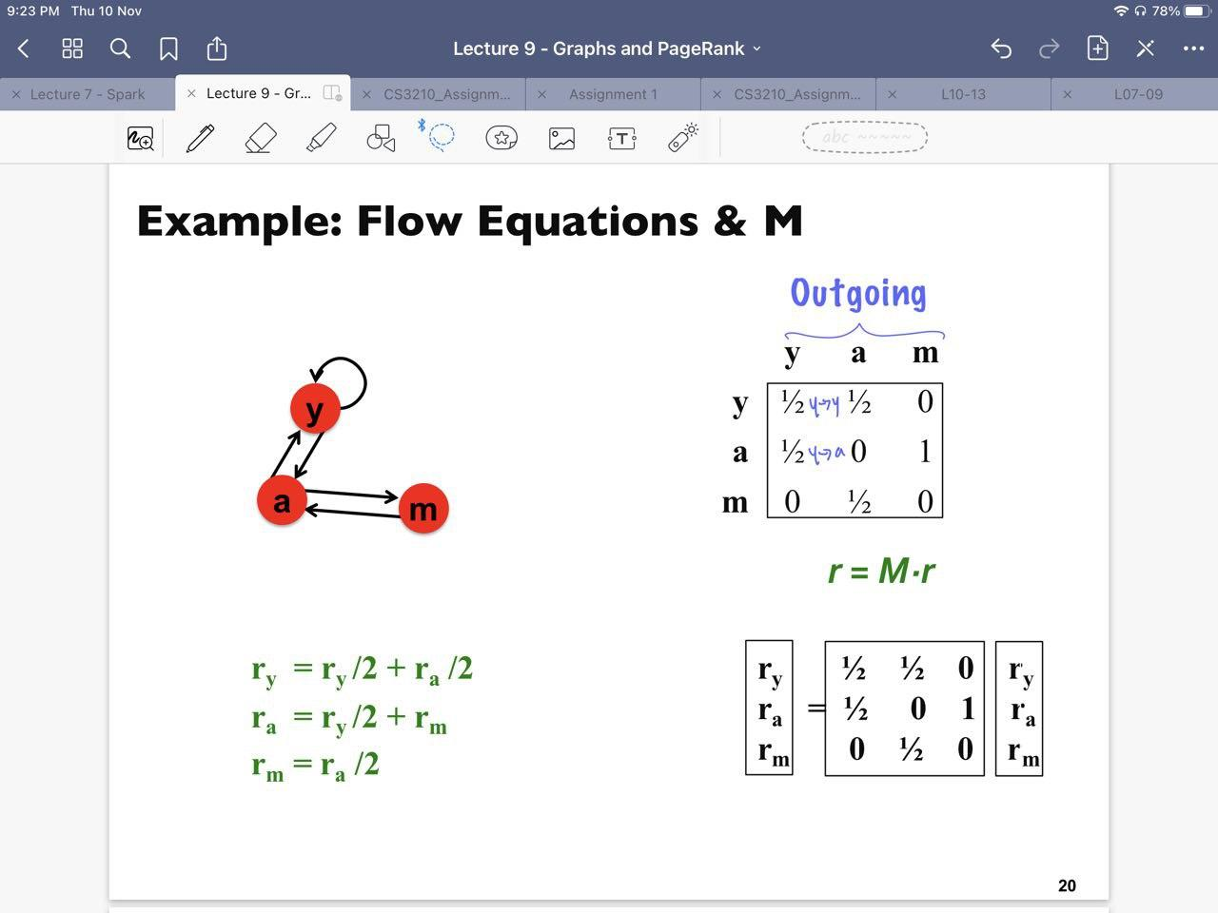

Power Iteration Method

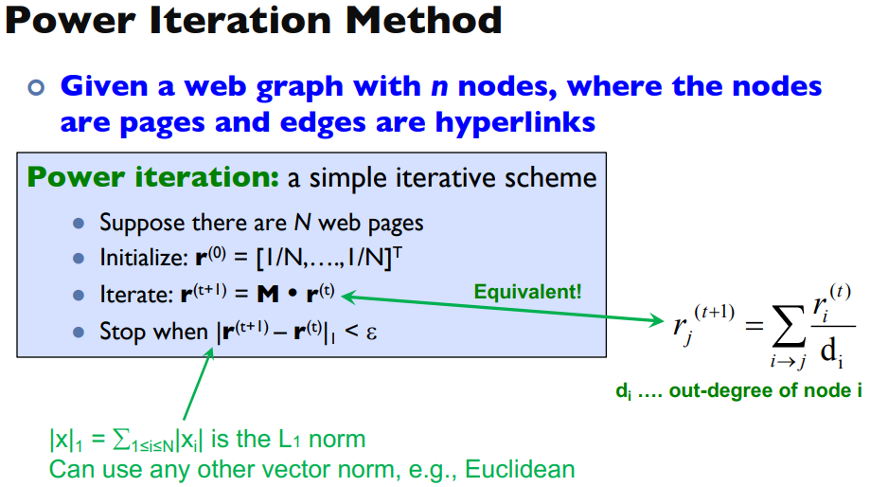

* At initialization, each page is equally important (1/N)
* Stop when rt+1 is close to rt → reach stable state and converge
* At each iteration, importance is passed along its outgoing edges to its neighbour

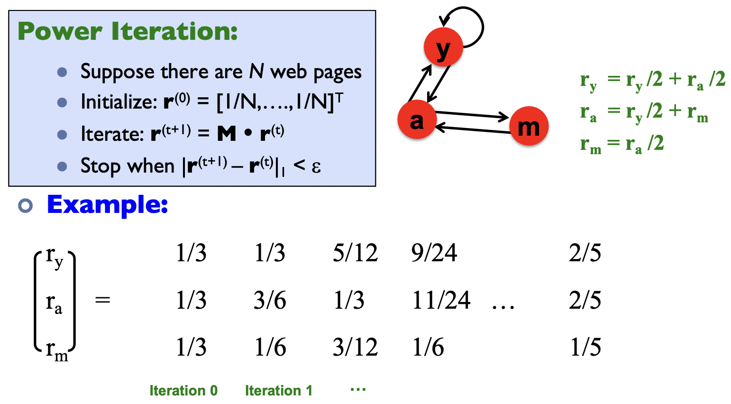

Random Walk Interpretation

* Same as power iteration just a different interpretation
* Page importance = probability of surfer going to that page

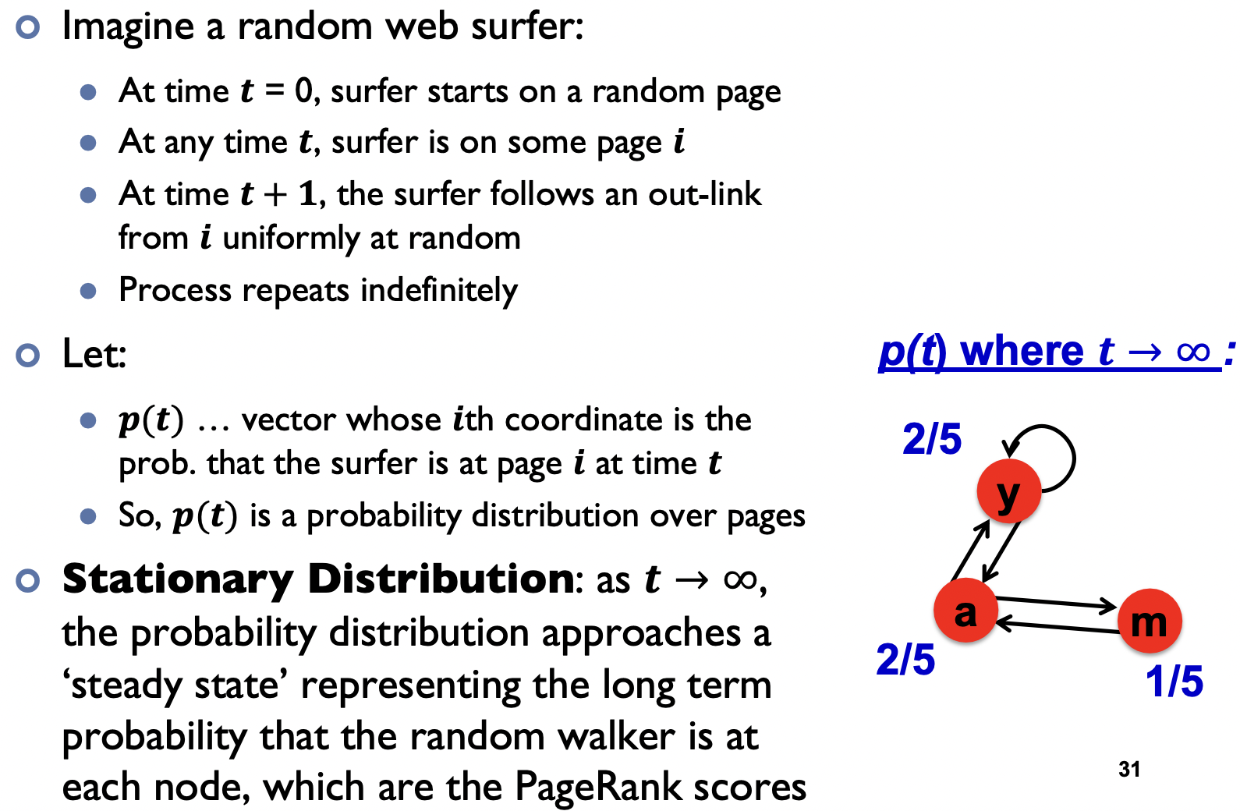

Follow link uniformly at random: $p(t+1)=M⋅p(t)$

Stationary state: $p_{s}=M⋅p_{s}$

* same formula as page rank: $r=M⋅r$

**Page rank does NOT always converge**

* Page rank is supposed to give identical stable result regardless of initial vector
* Example below is not a usual initialization (usual initialization has same values)

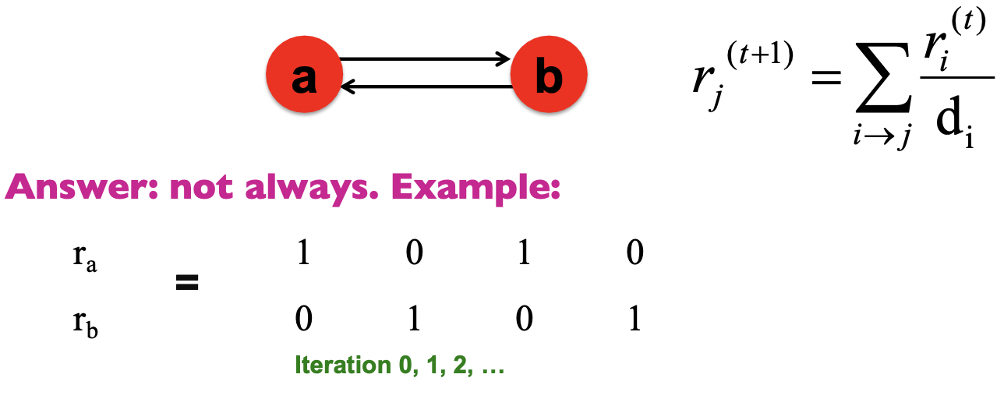

**PageRank does NOT converge to what we want**

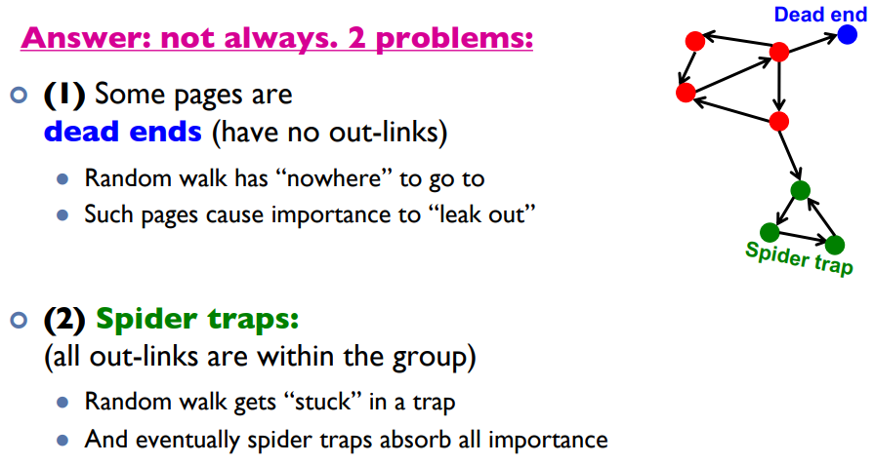

Dead ends

* POV of Importance: No one to pass importance to
* POV of random walk: No where to walk

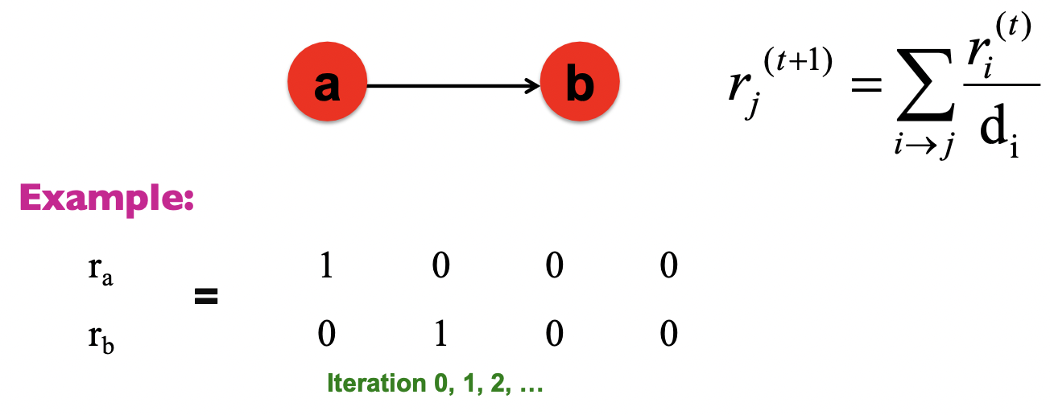

Spider traps (cycle)

* POV of importance: Absorbed by trap
* POV of r.w.: Walk in traps in circles
* Spider traps occur when random walks enter but cannot exit a part of the graph.
* This cannot happen for undirected (bidirectional) graphs.
* Spider traps may have self-loops (tutorial 3) but not all self-loops are spider traps (next eg y)
* If there are more than 1 spider traps in the graph, generally they will share the same importance. But depending on initialization, it is possible that 1 will absorb all importance.

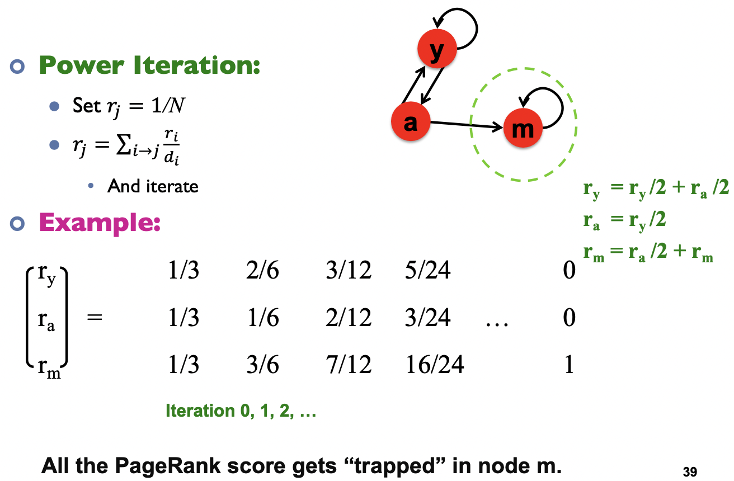

**PageRank with Teleports [SOLUTION]**

* At each time step, random surfer has 2 options
  + With probability ß, follow a link at random (regular)
  + With probability 1-ß, jump to some random page (teleport)
* Common values of ß = [0.8, 0.9]
* Dead ends → cause importance to “leak” out of the system
  + The matrix is not column stochastic
  + Solution: Make matrix column stochastic by always teleporting when at a dead end

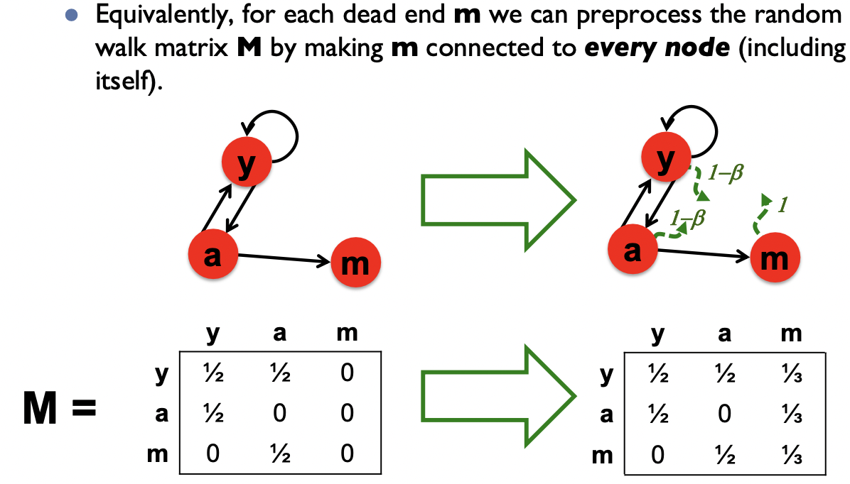

* Spider-traps → cause random walker to get stuck in them, absorbing all importance
  + Solution: teleport out of it in a finite number of steps

**Random Teleportation: Equations**

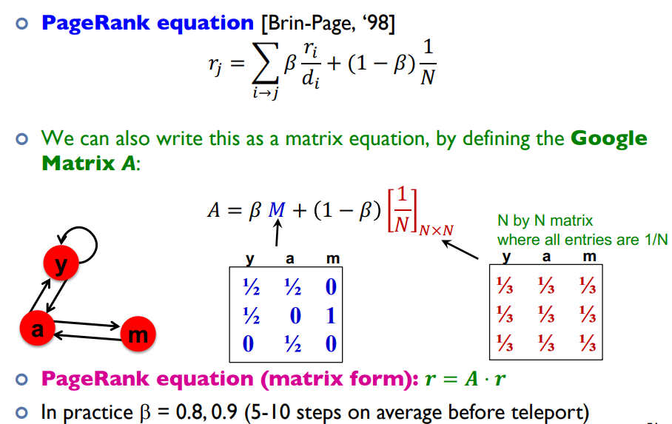

Problems with Page Rank

* Measures generic popularity of a page
  + Doesn’t consider popularity based on specific topics
  + Use Topic Specific Rank
* Uses a single measure of importance
  + Only considers in-links for importance
  + Use Hubs-and-Authorities
* Susceptible to Link spam
  + Artificial link topographies created in order to boost page rank
  + Uses TrustRank

**Topic Sensitive PageRank**

* Allows search queries to be answered based on interests of the user
* A is stochastic
* Weighted all pages in the teleport set S equally
  + Could assign diff weights too

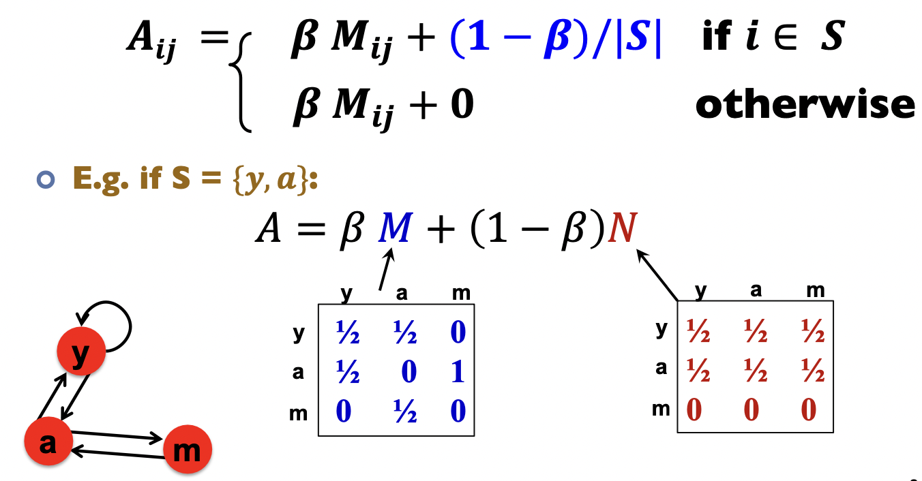

**Lecture 10: Graphs**

Features of graph algo:

* Local computations at each vertex
* Passing messages to other vertex

Think like a vertex: algorithms are implemented from the view of a single vertex, performing one iteration based on messages from its neighbour

* Similar to MapReduce, the user only implements a simple function, compute() → one vertex in one step
* Framework abstracts away scheduling and implementation details

**Pregel: Computational Model**

* Computation consists of a series of supersteps
* In each superstep, the framework invokes a user-defined function, compute(), for each vertex (conceptually in parallel)
* compute() specifies behavior at a single vertex v and a superstep s:
  + read messages sent to v in superstep (s - 1);
  + send messages to other vertices that will be read in superstep (s + 1);
  + read or write the value of v and the value of its outgoing edges (or even add or remove edges)
* Termination:
  + A vertex can choose to deactivate itself (vote to halt)
  + Is “woken up” if new messages received (stay inactive if no new msg)
  + Computation halts when all vertices are inactive

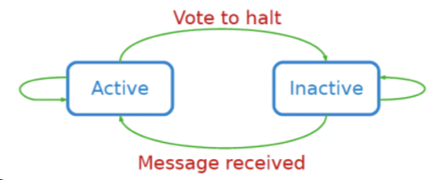

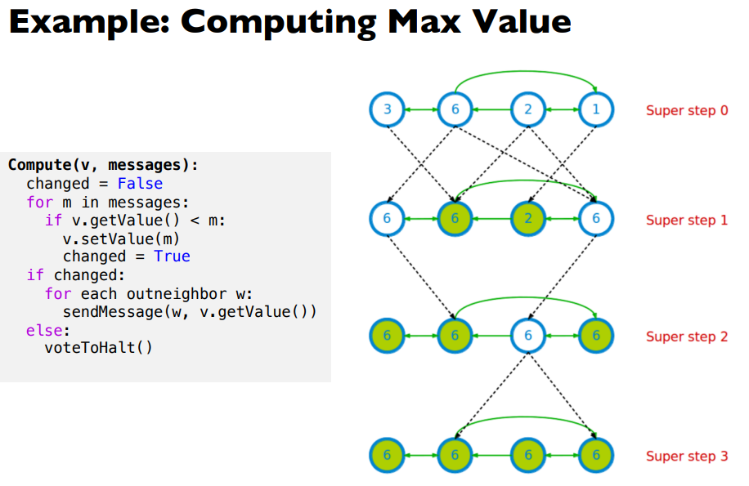

* Each vertex sends its current value (“message”) to its neighbours
* Update value = max(value, message)
* Repeat until all vertex values stop changing
* messages: array of prev messages this node has received

**Pregel: Implementation**

* Master & worker architecture
  + vertices are hash partitioned (by default) and assigned to workers (“edge cut”)
  + Each worker maintains the state of its portion of the graph in memory
  + Computations happen in memory
  + In each superstep, each worker loops through its vertices and executes compute()
  + Messages from vertices are sent
  + vertices on same worker → immediate operation
  + vertices on different worker → buffer delay as it is buffered locally and sent as a batch to reduce network traffic
* Fault tolerance
  + Checkpointing to persistent storage → like games checkpoint save 🕹️
  + Failure detected through heartbeats (check if still alive)
    - corrupt workers are reassigned and reloaded from checkpoints

**Giraph Architecture**

* Employs Hadoop’s Map phase to run computations
* Employs ZooKeeper (service that provides distributed synchronisation) to enforce barrier waits

**PageRank in Pregel**

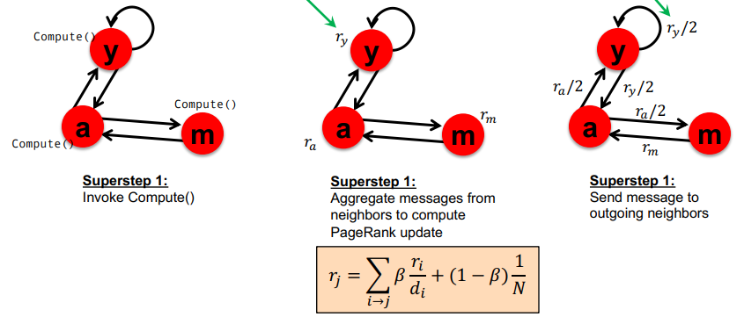

* rj is the message to be sent to other vertices
* ri/di is the message to be received from other vertices
* NOTE: to calculate pageRank all nodes must keep on sending its own value; if some votes to halt before others, the resulting rank will be wrong!!

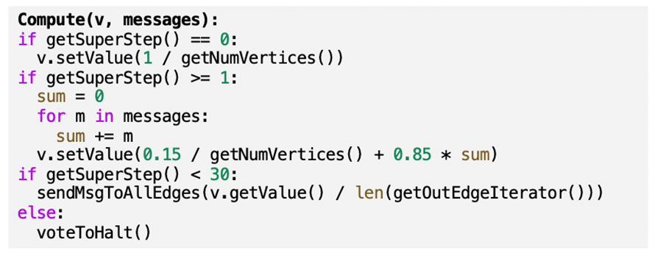

**Streams: Motivation**

* For data that arrives over time; it is not received all at once
  + Process their input as it is received
  + Different to offline or batch approaches that operate on full dataset, all at once

**Streaming Data**

* High volume of input elements enter at a rapid rate from input ports e.g. from a sensor, TCP connection, file stream
  + Elements of stream a.k.a tuples
  + Stream is potentially infinite; system cannot store the entire stream accessibly due to limited memory

Ad-Hoc queries: Cannot predict these queries, random intervals

Standing queries: Queries that are always there and called at regular intervals or answer is always there

**Reservoir Sampling**

Goal: maintain a uniform random sample of fixed size B over time

* Uniform random sample: each item has the same probability of being sampled
  + Probability = B/No. of elements = B/t
* At any point in time, reservoir is a uniform sample over entire stream that can be used to compute a wide variety of queries
* only needs to store a fixed size reservoir regardless of how large the data is → no data limit!!!
  + E.g. mean, variance, median
* In large data scenarios, approximations using a reasonable sized sample are accurate enough

Method

Input : stream {a1, a2,...}, reservoir size B

1. The first B items are inserted into the reservoir
2. When receiving at (t > B): with probability B/t, replace a random item in the reservoir with this item

**Running Mean and Variance [Optional]**

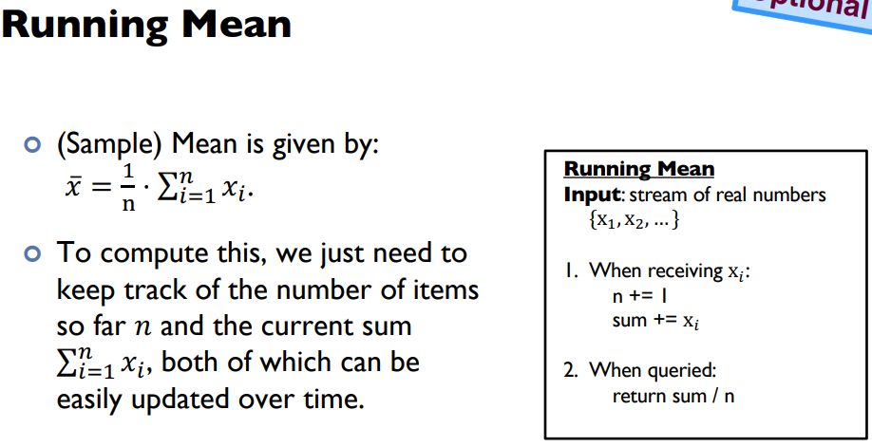

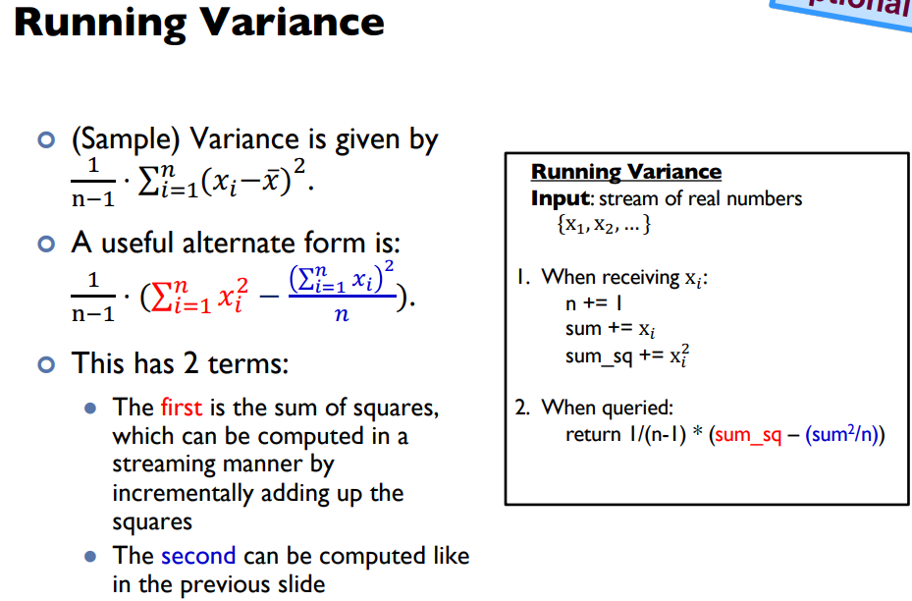

**Lecture 10: Delta Lake**

**Importance of Optimal Storage**

* Scalability and performance
* Transaction support
* Support for diverse data formats
* Support for diverse workloads
* Openness

**SQL Database**

* Designed to store structured data (i.e. table)
* Data adhere to a strict schema
  + allows DBMS to heavily co-optimize data storage and processing through an optimized query processing engines
* Very fast computation and strong transactional ACID guarantees on read/write operations
* Atomicity, Consistency, Isolation, Durability
* OLTP vs. OLAP
  + Online transaction processing (OLTP): traditional databases
  + Online analytical processing (OLAP): Data Warehouse

**Data Warehouse**

a central relational repository of integrated, historical data from multiple databases

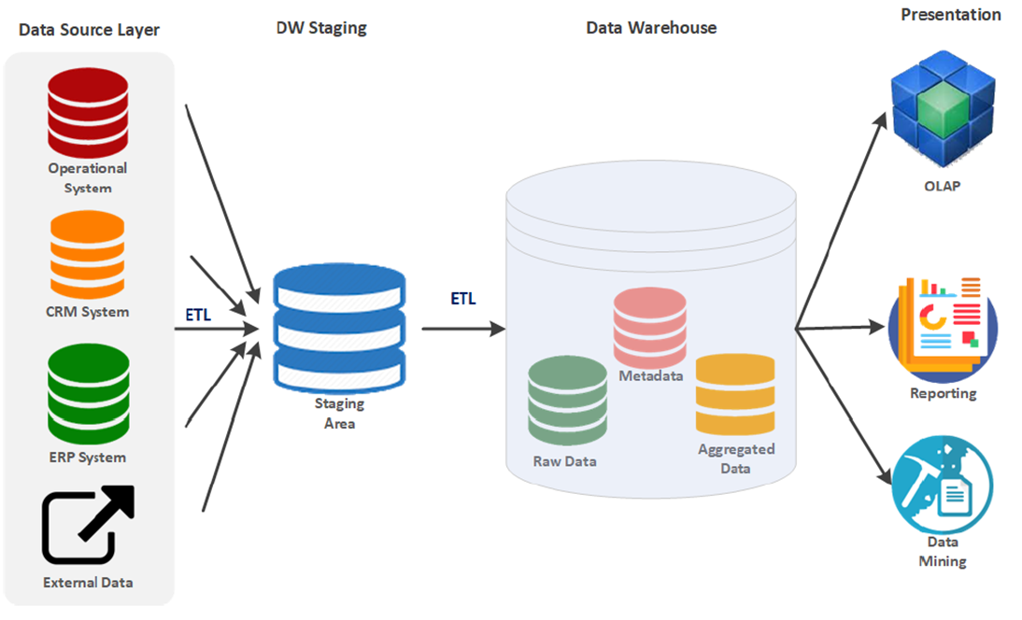

* Store large amounts of historical data from different sources
* Very reliable with strong transactional ACID guarantees
* Modeled with standard star-schema modeling techniques
* Suited for business intelligence and reporting

Data Warehouses have a hard time addressing

1. Growth in data sizes (Volume):

Extremely expensive to scale out

1. Growth in the diversity of analytics (Vareity): Do not support non–SQL based analytics very well

**Data Lake**

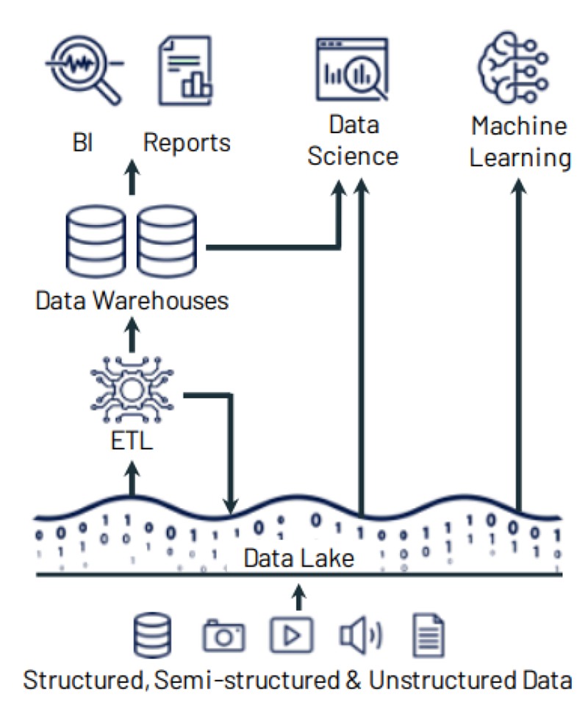

cost-effective central repository to store data at any scale

* distributed storage solution, runs on commodity hardware, and easily scales out horizontally
* data is saved as files with open formats
* any processing engine can read and write them using standard APIs
* decouples the distributed storage system from the distributed compute system
* Allows each system to scale out as needed by the workloads

Companies build data lakes by independently choosing

1. Storage system: HDFS, S3, Cloud and etc.
2. File format:
   1. Structured: Parquet, ORC
   2. semi-structured: JSON
   3. unstructured: text, images, audio, video
3. Computing / Processing engine(s):
   1. batch processing: Spark, Presto, Apache Hive
   2. stream processing: Spark, Apache Flink
   3. machine learning library: Spark MLlib, scikit-learn, R

Pros

* Flexibility on choosing storage, data format and processing engines
* A much cheaper solution than databases explosive growth of the big data ecosystem

Cons:

* Fail to provide ACID guarantees
* Building and maintaining an effective data lake requires expert skills
* Easy to ingest data but very expensive to transform data to deliver business values
* Data quality issues due to the lack of schema enforcement

**Data Lakehouse**

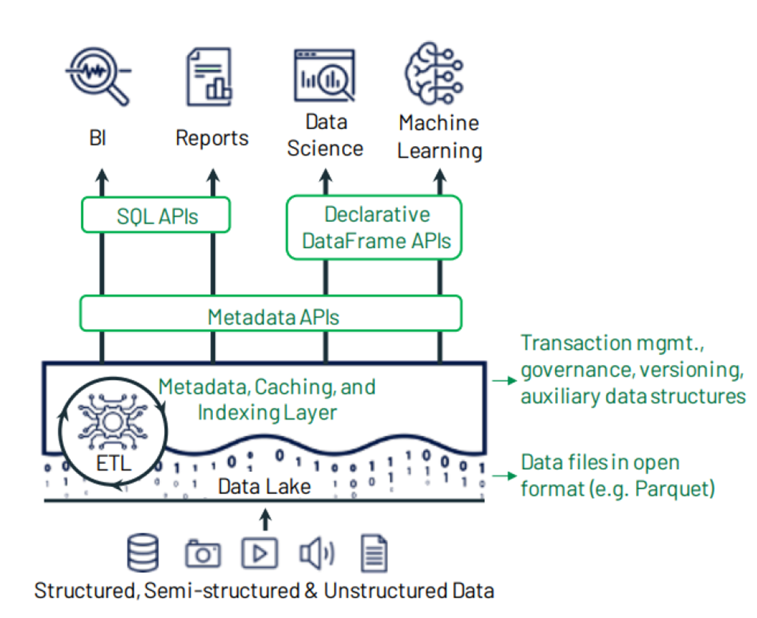

Merges both data lake and warehouse:

1. flexibility, low cost, and scale of a data lake
2. data management and ACID transactions of data warehouses

Great for both business intelligence and machine learning/AI

Especially good match for cloud environment

with separate storage and computing resources

**Delta Lake**

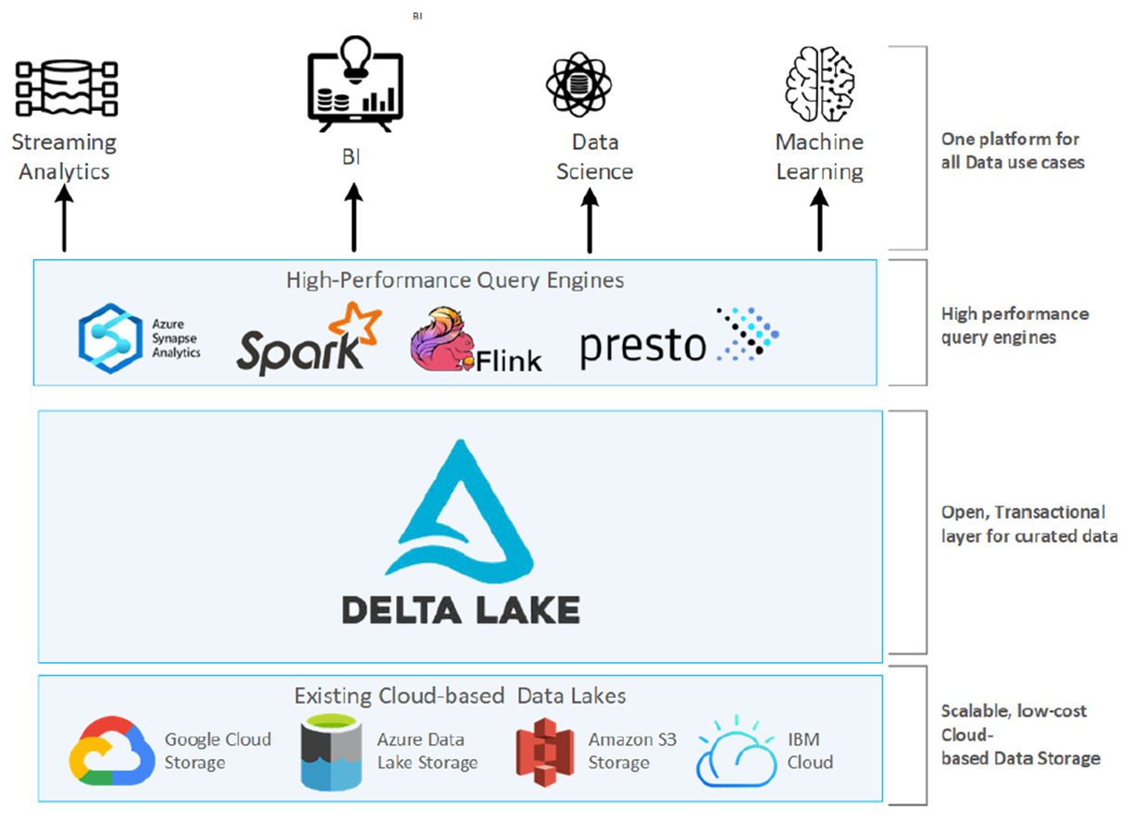

the metadata, caching and indexing layer on top of a data lake storage that provides an abstraction level to serve ACID transactions and other management features

* Transactional ACID guarantees
* Full DML (Data Manipulation Language) support
* Audit History
* Unification of batch and streaming into one processing model
* Schema enforcement and evolution
* Rich metadata support and scaling

**Delta Lake Transaction Log (DeltaLog)**

An ordered record of every transaction made against a Delta table since it was created.

* Acts as a single source of truth and tracks all changes made to the table.
* The main goal is to enable multiple readers and writers to operate on a given version of a dataset simultaneously.
* It is at the core of many important features
  + ACID transactions
    - Spark looks at the logs to get the latest version of the table
    - If operation was not recorded, it never happened.
  + Scalable metadata handling
  + Time travel

Uses standard Parquet file with additional metadata

Parquet Files

* Column oriented: perform compression on a column-by-column basis
* Open source
* Self-describing: actual data + metadata (schema & file structure)

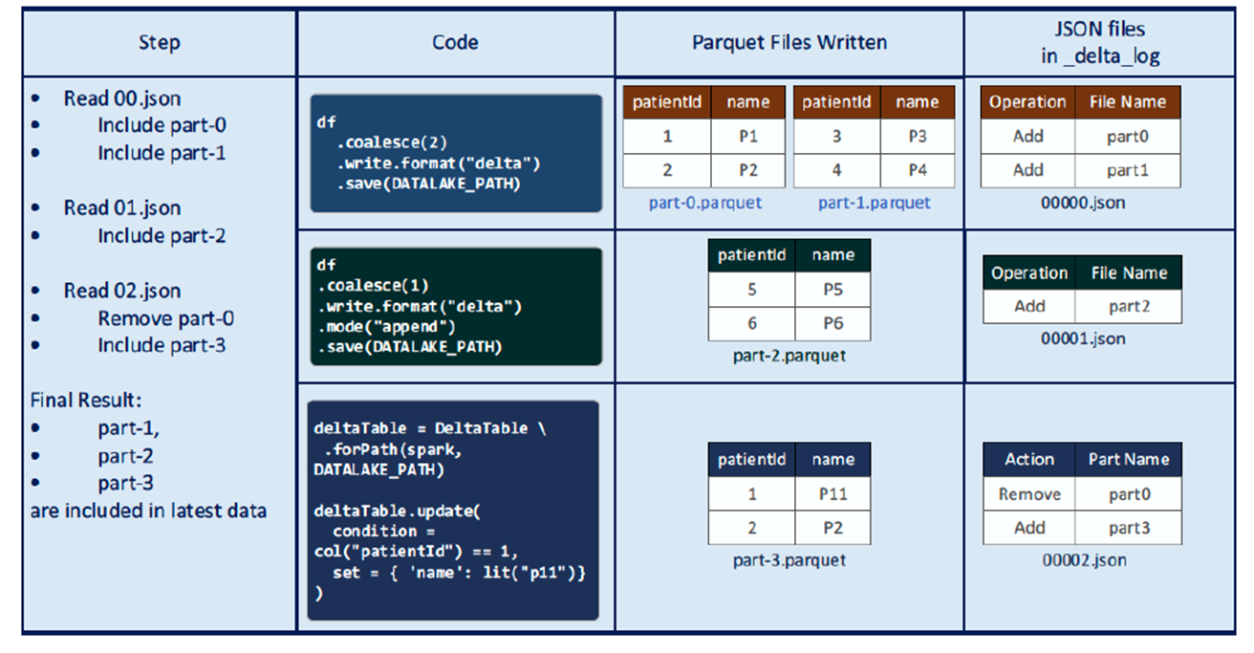

Possible actions in a transaction log entry:

* Add file
* Remove file
* Update Metadata
* Set Transaction
* Change Protocol
* Commit Info

**Tutorial 2**

**NoSQL**

BASE vs ACID

BASE = Basically Available, Soft state, Eventually consistent

ACID = Atomicity, Consistency, Isolation, and Durability

By giving up ACID constraints, one can improve performance.

Why horizonal scalability over vertical scalability?

Less expensive, using commodity servers.

Key-value stores vs document stores?

Key-value store:

* Improves scalability and efficiency – writing or reading user pages is faster.
* No need for complex queries or based on the content of user pages – just reads and writes.
* May be acceptable for user pages to be slightly stale – thus eventual consistency is acceptable

Document store:

* Flexible schema may be beneficial (e.g. special types of vehicles may require different sets of fields)
* Unlike key-value stores, document stores allow for queries based on fields of a document

**Spark**

Why Spark is more suitable for iterative processing compared to Hadoop?

Spark stores most of its intermediate results in memory, making it faster especially for iterative processing.

Advantages of using schema in Spark

Type safety

3 spark features for relational databases

1. Schema support
2. query optimization
3. high level languages

Major problem if Spark also uses replications for reliability

* consumes a lot of memory.
* memory is much more scarce than disk space

Explain how the following program can be sped up

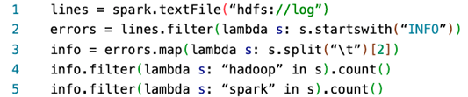

* lines 4-5 are recomputing the RDD by re-reading it from the file.
* So, we should add info.cache() (or info.persist()) before line 4, to cache the RDD in disk so it doesn’t have to be re-computed in line 5.

RDD cannot reside in the hard disk?

False. RDD can also be in the disk if out of memory.

**Tutorial 3**

NOTE: If did not specify to calculate the simultaneous eqn don’t waste time!!!

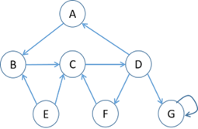

* No deadends → G is not considered dead end as importance is not “leaked” it is trapped within G, “cannot walk out of G”
* 2 Spider traps
  + Large outer trap → importance not going out to E
  + G is a spider trap since G absorbs all importance

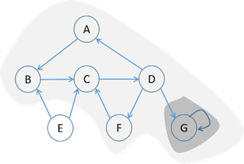

In Topic-specific PageRank, random walker will teleport to any page with equal probability?

False. Random walker only teleports to a topic-specific set of “relevant” pages.

**Tutorial 4**

Topic-specific PageRank will generate the same ranking for any set of web pages.

False. It depends on the teleport set.

Problem with skewed (i.e. highly imbalanced) data distributions

* Poor parallelization
* High memory requirement in some workers
* high network I/O for some workers.
* Same problems apply to both Pregel&MapReduce

Show pseudocode for the compute() function for the PageRank with teleport (β = 0.85) over vertices algorithm in Pregel / Giraph. Run 30 iterations and then stop

* Note initialization step (getSuperStep() == 0)

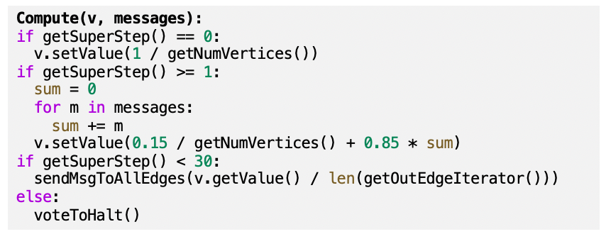

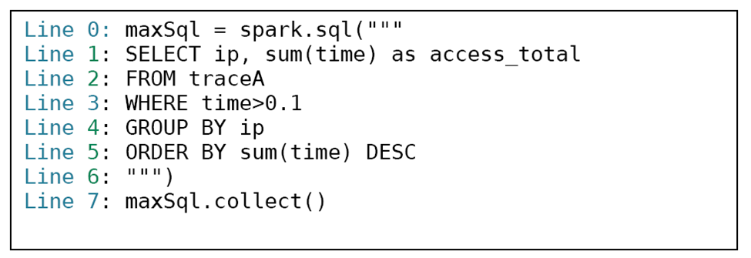Potential performance bottlenecks?

Depending on whether the dataframe has been in the RAM, if not reading traceA (Line 1-3) may incur potential I/O cost

Depending on the size of data generated from Line 3, Line 4 & 5 can also be the bottleneck as both operations are wide transformation and thus require data shuffling through the network I/O.

If the grouped data after Line 4 is highly skewed (e.g. a super big size of data for certain ip address), Line 5 will have task straggler issue, i.e. certain tasks takes much longer time than the other tasks to complete.

Line 7 may return too many results. We can add LIMIT to the SQL query to limit the number of results or use .show()

**Mock Paper**

In Spark, some functions including groupByKey() and join() require the data in the RDDs we are processing to pass through the master node, and hence can cause a significant slowdown.

False: The data passes through worker nodes (wide dependencies), not the master node

Let G be any undirected graph. In the PageRank algorithm, the problem associated with spider traps cannot occur in this case

True: Spider traps occur when random walks enter but cannot exit a part of the graph. This cannot happen for undirected graphs.

In PageRank, self-loops cause the same problem as dead-ends as discussed in lecture, and should be handled by preprocessing the random walk matrix (M) in the same way as for dead-ends

* False: Self-loops do not cause the issue of “leaking pagerank” like dead-ends.
* Self-loops can be handled similarly to normal edges.

In topic-sensitive PageRank, the node with the highest topic-sensitive PageRank score is always in the teleport set.

False: A node could be outside the teleport set, but receive a lot of PageRank from its incoming neighbours.

* E.g. 1: node 3 not in S but has a higher page rank

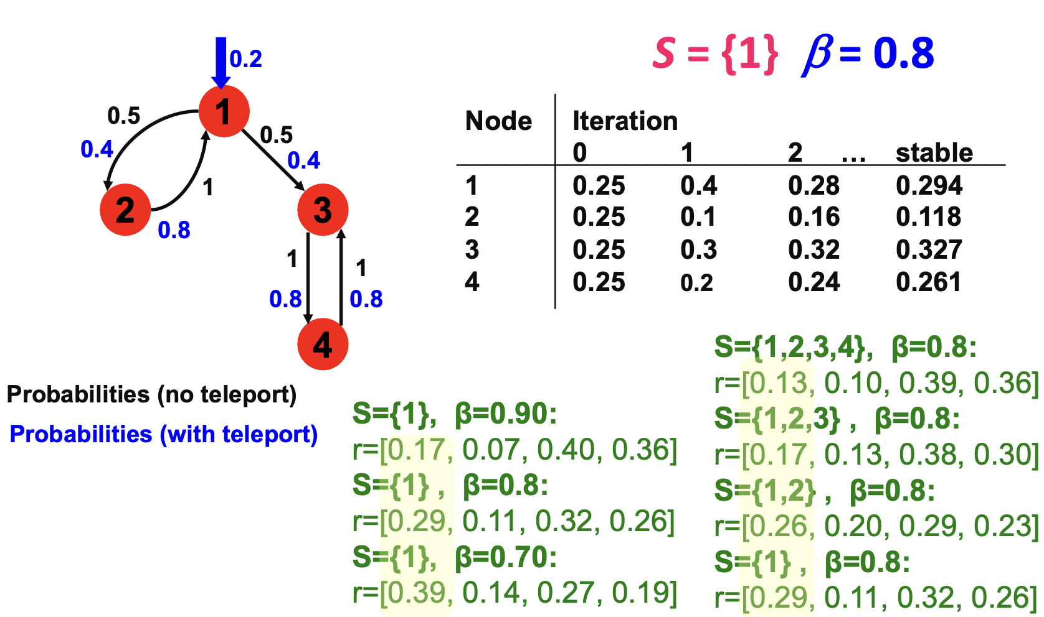

In stream processing systems, if the length of the stream keeps increasing without bound, the stream processing system will eventually run out of memory.

False: Stream processing systems are generally designed to process the data as it comes, without storing the entire dataset.

running jobs with the sortBy() transformation (i.e. sort the data) or collect() on an RDD cause the Spark job to run very slowly, but the filter() transformation is much faster.

* sortBy(): wide dependency → data needs to be shuffled
* collect(): data needs to be sent to the master node
* filter(): narrow dependency → data is processed locally
* Same trend with small data size: latency involved in communication between nodes can dominate the (computation) time cost.

1: info = spark.textFile(“hdfs://log”)

2: info = info.map(lambda s: s.split(“ ”)[2])

3: info.collect()

4: info.filter(lambda s: “hadoop” in s).count()

5: info.filter(lambda s: “spark” in s).count()

Program crashes on a large cluster when processing a massive log file. Explain.

* collect() sends all the data to the master node, causing a crash as the dataset is too large to fit in memory.
  + collect() won’t automatically discard data if too large
* Delete line 3 to fix the problem, as it does not affect the results of the program.
* count() in comparison with collect() takes up significantly less memory, less amount of data to be sent over.
* collect() vs show() → show() takes up less memory than collect() as well as show() automatically truncates to first 20 entries (but can crash if user show too many entries)

Modifying PageRank algorithm by changing the stopping condition to stop once every vertex’s PageRank value changes by less than 0.01

→ make the compute() function for each vertex call voteToHalt() whenever the difference between the vertex’s current and previous value is less than 0.01

* This will give the wrong result.
* E.g. node i reaches the stopping condition and votes to halt, but its neighbours have not reached the stopping condition.
* Then node i will vote to halt and will not send messages to its neighbours, resulting in the wrong computation of PageRank on its neighbours. OR
* Graphs may not be converging and can result in the PageRank algorithm to keep on sending messages indefinitely.

Assume that we use topic-sensitive PageRank to obtain scores for webpages for the “data science” topic. There is a set A of webpages, none of which are in the “data science” seed set (i.e. teleport set) S. Assume that for each page in A, if it has any incoming links, these links can only come from other pages in A. Is it true that all pages in A have a topic-sensitive PageRank score of 0?

Yes. S is a spider trap.